Top of Form

Question 1: **Correct**

Please evaluate the following statement and select **Yes** if the statement is true, otherwise select **No**.

Azure Platform as a Service (PaaS) service offering provides full control over the operating system that hosts your applications.

* ​

Yes

* ​

No

**(Correct)**

**Explanation**

Azure PaaS solutions don’t allow access to the operating system.

For example, Azure App service provides an environment for you to host your web applications. What actually happens is that your applications wil be deployed on virtual machines, running a web server process – Apache or IIS.

However, you have no direct access to the virtual machines, the operating system or Apache/IIS – the web service that is run on the VMs.

**Reference:**

<https://azure.microsoft.com/en-gb/overview/what-is-paas/>

**Quick Preview:**

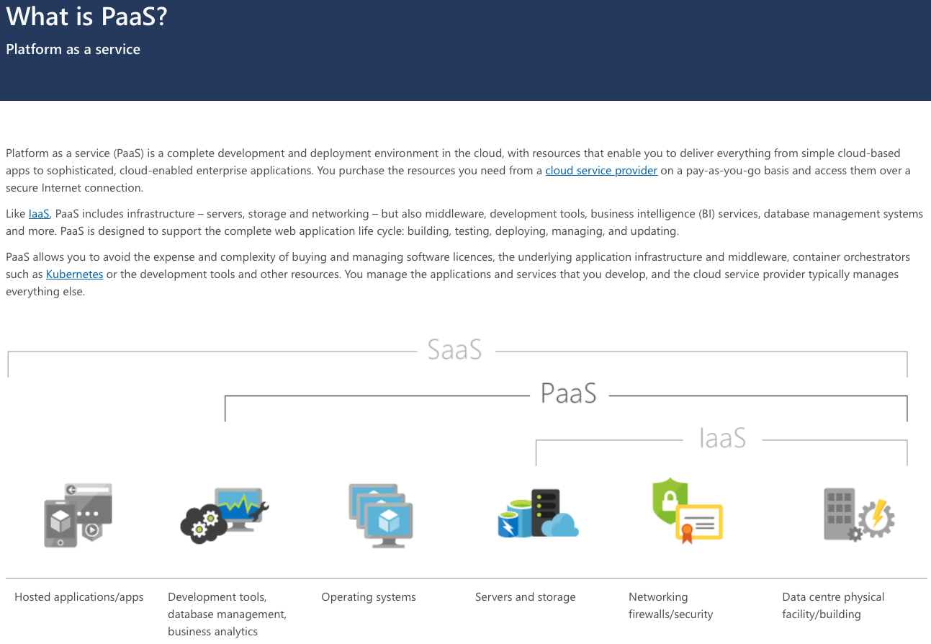

Bottom of Form

Top of Form

Question 2: **Correct**

Please evaluate the following statement and select **Yes** if the statement is true, otherwise select **No**.

While using an Azure PaaS solution that hosts your web apps, you can change the pricing tier to add additional memory.

* ​

Yes

**(Correct)**

* ​

No

**Explanation**

Multiple pricing plans are available for Azure App Service and it's really easy to choose an option (App Service Plan) that can accommodate your business and technical needs.

Depending on the App Service plan you choose, different features will be available to you and, of course, different computing power and storage space.

**Reference:**

<https://azure.microsoft.com/en-us/pricing/details/app-service/windows/>

**Quick Preview:**

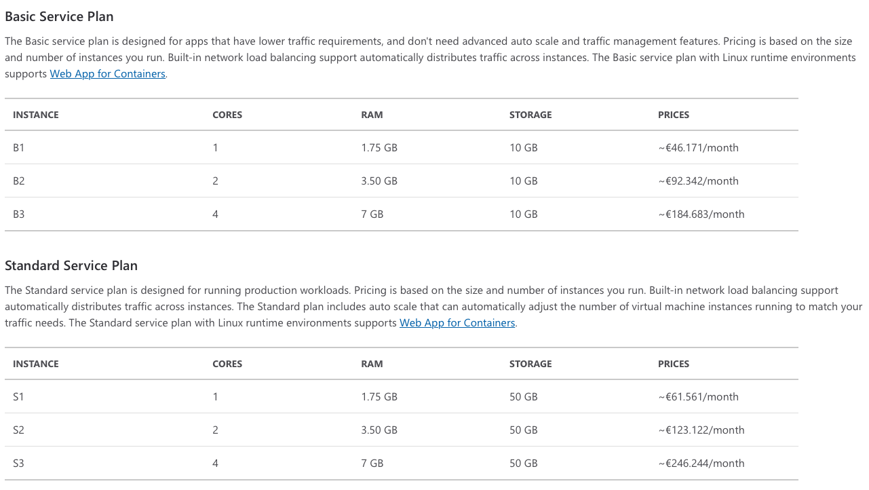

Bottom of Form

Top of Form

Question 3: **Correct**

Please evaluate the following statement and select **Yes** if the statement is true, otherwise select **No**.

While running a PaaS application in Azure, you can configure your solution to automatically scale the number of VM instances, based on demand.

* ​

Yes

**(Correct)**

* ​

No

**Explanation**

Azure PaaS solutions allow you to scale the platform automatically.

For example, when you deploy your apps in Azure using Azure App Service, advanced capabilities such as autoscaling are available based on the App Service plan you are using.

Autoscaling is the capability that allows your environment to adapt to traffic demand changes, either up or down. Also, please note that autoscaling is not available on all App Service plans, so you would need to check this in advance.

Simply put, if unexpected traffic is received by your application, autoscaling will add more computing resources to your solution, so that overall performance is maintained. Once the environment returns to usual traffic conditions, the extra computing resources are removed.

As you can imagine, autoscaling also helps keeping your costs low in Azure.

**Reference:**

<https://docs.microsoft.com/en-us/azure/azure-monitor/platform/autoscale-get-started>

**Quick Preview:**

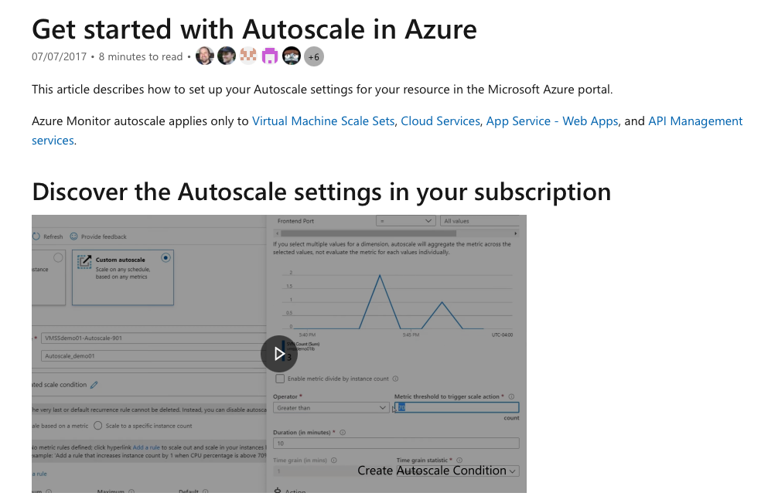

Bottom of Form

Top of Form

Question 4: **Correct**

*Note: This question is part of a series of questions that present the same scenario. Please read the scenario and evaluate if the solution presented meets the requirements.*

Your company has decided to migrate some of its services to Microsoft Azure. The company CTO wants to make sure that services deployed to Azure virtual machines are available if a single data center fails.

**Solution: You decide to deploy the virtual machines to a virtual machine scale set.**

Does this meet the goal?

* ​

Yes

* ​

No

**(Correct)**

**Explanation**

In order to meet the technical requirements, you would need to make sure that virtual machines are deployed in at least two different availability zones. Azure availability zones really represent Azure data centers.

If you deploy your virtual machines in different data centers, in case something goes wrong and one data center fails, services will continue to run because they will be served from the virtual machines running in the other data center.

In this specific scenario the proposed solution is to deploy virtual machines to a virtual machine scale set. While using virtual machine scale sets, you can deploy your virtual machines in the same availability zone or in different availability zones. Because the proposed solution doesn’t specify that the VMSS will use different availability zones, the proposed solution doesn’t meet the technical goal.

*“Azure virtual machine scale sets let you create and manage a group of load balanced VMs.*

*The number of VM instances can automatically increase or decrease in response to demand or a defined schedule. Scale sets provide high availability to your applications, and allow you to centrally manage, configure, and update a large number of VMs.” - microsoft.com*

**Reference:**

<https://docs.microsoft.com/en-us/azure/virtual-machine-scale-sets/overview>

**Quick Preview:**

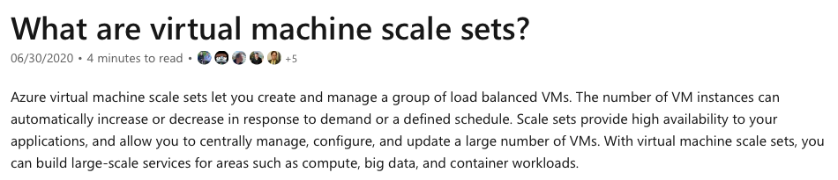

Bottom of Form

Top of Form

Question 5: **Correct**

*Note: This question is part of a series of questions that present the same scenario. Please read the scenario and evaluate if the solution presented meets the requirements.*

Your company has decided to migrate some of its services to Microsoft Azure. The company CTO wants to make sure that services deployed to Azure virtual machines are available if a single data center fails.

**Solution: You decide to deploy the virtual machines to two or more scale sets.**

Does this meet the goal?

* ​

Yes

* ​

No

**(Correct)**

**Explanation**

In order to meet the technical requirements, you would need to make sure that virtual machines are deployed in at least two different availability zones. Azure availability zones really represent Azure data centers.

If you deploy your virtual machines in different data centers, in case something goes wrong and one data center fails, services will continue to run because they will be served from the virtual machines running in the other data center.

In this specific scenario the proposed solution is to deploy virtual machines to multiple virtual machine scale sets. While using virtual machine scale sets, you can deploy your virtual machines in the same availability zone or in different availability zones. Because the proposed solution doesn’t specify that the virtual machine scale sets will use different availability zones, the proposed solution doesn’t meet the technical goal.

*“Azure virtual machine scale sets let you create and manage a group of load balanced VMs.*

*The number of VM instances can automatically increase or decrease in response to demand or a defined schedule. Scale sets provide high availability to your applications, and allow you to centrally manage, configure, and update a large number of VMs.” - microsoft.com*

**Reference:**

<https://docs.microsoft.com/en-us/azure/virtual-machine-scale-sets/overview>

**Quick Preview:**



Bottom of Form

Top of Form

Question 6: **Correct**

*Note: This question is part of a series of questions that present the same scenario. Please read the scenario and evaluate if the solution presented meets the requirements.*

Your company has decided to migrate some of its services to Microsoft Azure. The company CTO wants to make sure that services deployed to Azure virtual machines are available if a single data center fails.

**Solution: You decide to deploy the virtual machines to two or more availability zones.**

Does this meet the goal?

* ​

Yes

**(Correct)**

* ​

No

**Explanation**

In order to meet the technical requirements, you would need to make sure that virtual machines are deployed in at least two different availability zones. Azure availability zones really represent Azure data centers.

If you deploy your virtual machines in different data centers, in case something goes wrong and one data center fails, services will continue to run because they will be served from the virtual machines running in the other data center.

In this specific scenario the proposed solution is to deploy virtual machines to two or more availability zones, which meets the technical goal.

*“An Availability Zone is a high-availability offering that protects your applications and data from datacenter failures.*

*Availability Zones are unique physical locations within an Azure region. Each zone is made up of one or more datacenters equipped with independent power, cooling, and networking.*

*To ensure resiliency, there's a minimum of three separate zones in all enabled regions. The physical separation of Availability Zones within a region protects applications and data from datacenter failures.” - microsoft.com*

**Reference:**

<https://docs.microsoft.com/en-us/azure/availability-zones/az-overview>

**Quick Preview:**

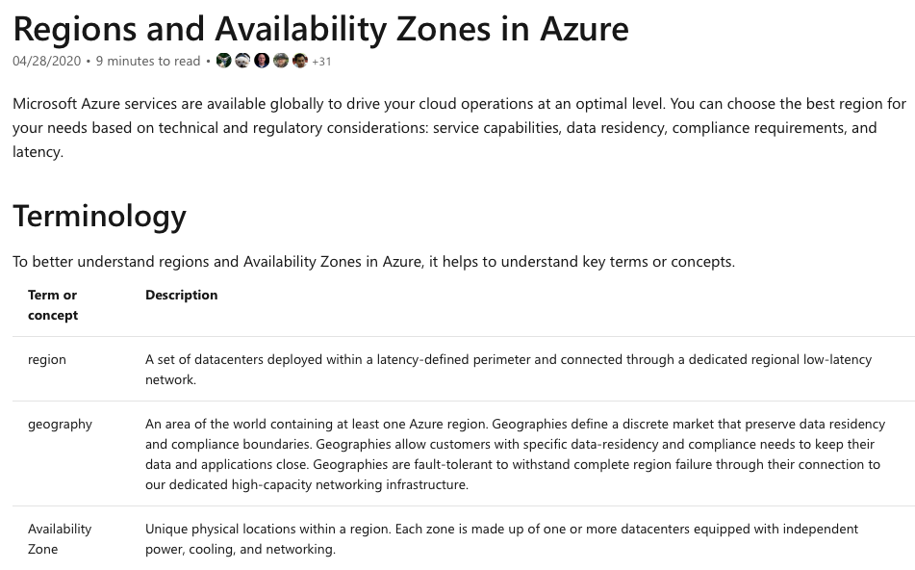

Bottom of Form

Top of Form

Question 7: **Correct**

*Note: This question is part of a series of questions that present the same scenario. Please read the scenario and evaluate if the solution presented meets the requirements.*

Your company has decided to migrate some of its services to Microsoft Azure. The company CTO wants to make sure that services deployed to Azure virtual machines are available if a single data center fails.

**Solution: You decide to deploy the virtual machines to two or more regions.**

Does this meet the goal?

* ​

Yes

**(Correct)**

* ​

No

**Explanation**

At a minimum, in order to meet the technical requirements, you would need to make sure that virtual machines are deployed in at least two different availability zones. Azure availability zones really represent Azure data centers. Azure Regions include multiple availability zones.

If you deploy your virtual machines in different data centers, either in different availability zones or different regions, in case something goes wrong and one data center fails, services will continue to run because they will be served from the virtual machines running in the other data center.

In this specific scenario the proposed solution is to deploy virtual machines to two or more regions, which definitely meets the technical goal. At a minimum, and in order to minimize costs, you would need to deploy the virtual machines into two Azure availability zones.

*“A region is a set of datacenters deployed within a latency-defined perimeter and connected through a dedicated regional low-latency network. Azure gives you the flexibility to deploy applications where you need to, including across multiple regions to deliver cross-region resiliency.” - microsoft.com*

**Reference:**

<https://docs.microsoft.com/en-us/azure/virtual-machines/regions>

**Quick Preview:**

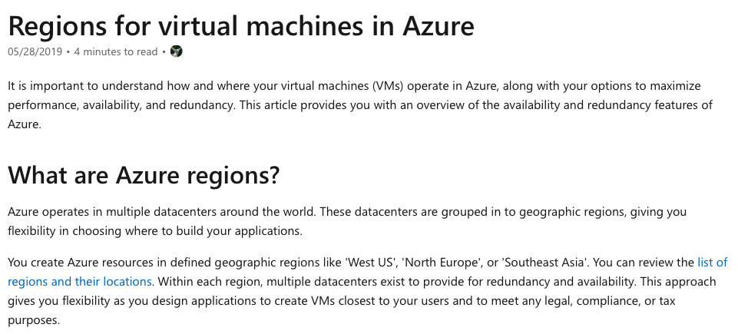

Bottom of Form

Top of Form

Question 8: **Correct**

*Note: This question is part of a series of questions that present the same scenario. Please read the scenario and evaluate if the solution presented meets the requirements.*

Your company has decided to migrate some of its services to Microsoft Azure. The company CTO wants to make sure that services deployed to Azure virtual machines are available if a single data center fails.

**Solution: You decide to deploy the virtual machines to two or more resource groups.**

Does this meet the goal?

* ​

Yes

* ​

No

**(Correct)**

**Explanation**

At a minimum, in order to meet the technical requirements, you would need to make sure that virtual machines are deployed in at least two different availability zones. Azure availability zones really represent Azure data centers. Azure Regions include multiple availability zones.

If you deploy your virtual machines in different data centers, either in different availability zones or different regions, in case something goes wrong and one data center fails, services will continue to run because they will be served from the virtual machines running in the other data center.

In this specific scenario the proposed solution is to deploy virtual machines to two or more resource groups, which doesn’t meet the technical goal. At a minimum, and in order to minimize costs, you would need to deploy the virtual machines into two Azure availability zones.

Simply put, a resource group represents a container for all resources that you deploy in Azure. Other than that, resource groups don’t offer any other functionalities or features, such as high availability and redundancy, which are requested and needed in this scenario.

*“A resource group is a container that holds related resources for an Azure solution. The resource group can include all the resources for the solution, or only those resources that you want to manage as a group.*

*You decide how you want to allocate resources to resource groups based on what makes the most sense for your organization. Generally, add resources that share the same lifecycle to the same resource group so you can easily deploy, update, and delete them as a group.*

*The resource group stores metadata about the resources. Therefore, when you specify a location for the resource group, you are specifying where that metadata is stored. For compliance reasons, you may need to ensure that your data is stored in a particular region.” - microsoft.com*

**Reference:**

<https://docs.microsoft.com/en-us/azure/azure-resource-manager/management/overview#resource-groups>

**Quick Preview:**

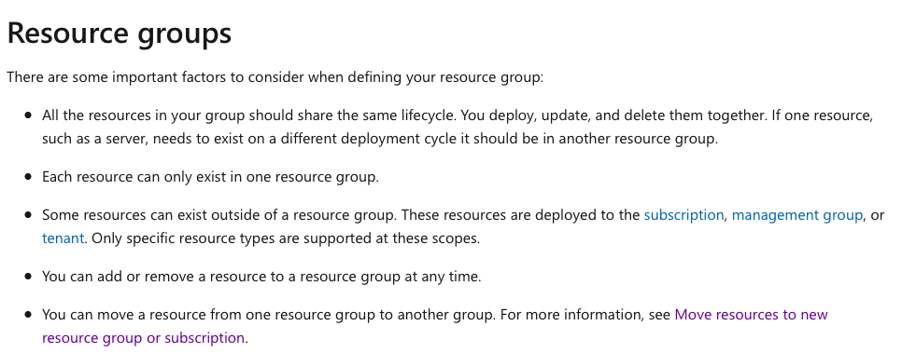

Bottom of Form

Top of Form

Question 9: **Correct**

Please evaluate the following statement and select **Yes** if the statement is true, otherwise select **No**.

Azure Functions represents a serverless computing Azure service offering.

* ​

Yes

**(Correct)**

* ​

No

**Explanation**

Azure provides a range of serverless execution environments, fully managed services and a comprehensive set of developer tools and services to build your applications.

Azure Functions represents the platform available in Azure where you can run serverless code.

**Microsoft documentation states the following:**

*“Azure Functions is a serverless compute service that lets you run event-triggered code without having to explicitly provision or manage infrastructure.*

*Serverless functions - Execute code, written in the language of your choice, with Azure Functions, an event-driven compute experience.” - microsoft.com*

**Reference:**

<https://azure.microsoft.com/en-gb/services/functions/>

**Quick Preview:**

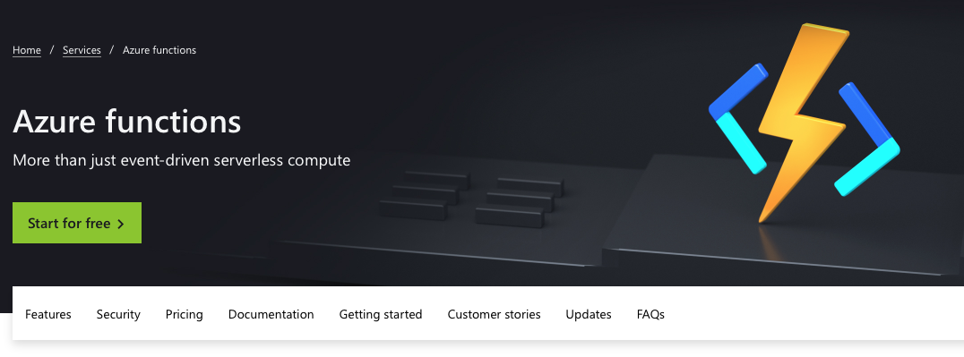

Bottom of Form

Top of Form

Question 10: **Correct**

Please evaluate the following statement and select **Yes** if the statement is true, otherwise select **No**.

You can use Azure App Service to host web applications in Azure.

* ​

Yes

**(Correct)**

* ​

No

**Explanation**

The statement is definitely true, this is what Azure App Service does.

**Microsoft documentation states the following:**

*“Azure App Service is an HTTP-based service for hosting web applications, REST APIs, and mobile back ends. You can develop in your favorite language, be it .NET, .NET Core, Java, Ruby, Node.js, PHP, or Python. Applications run and scale with ease on both Windows and Linux-based environments.” - microsoft.com*

**Reference:**

<https://docs.microsoft.com/en-us/azure/app-service/overview>

**Quick Preview:**

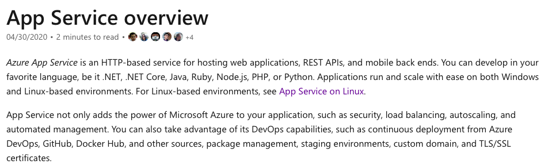

Bottom of Form

Top of Form

Question 11: **Correct**

Please evaluate the following statement and select **Yes** if the statement is true, otherwise select **No**.

Azure Databricks is a big data analysis Azure service used for machine learning.

* ​

Yes

**(Correct)**

* ​

No

**Explanation**

Azure Databricks is a data analytics platform optimized for the Microsoft Azure cloud services platform. The main use case for Azure Databricks is **big data** **analysis**.

**Microsoft documentation states the following:**

*“Azure Databricks is a data analytics platform optimized for the Microsoft Azure cloud services platform. Azure Databricks offers three environments for developing data intensive applications: Databricks SQL, Databricks Data Science & Engineering, and Databricks Machine Learning.*

*Databricks Data Science & Engineering (sometimes called simply "Workspace") is an analytics platform based on Apache Spark. It is integrated with Azure to provide one-click setup, streamlined workflows, and an interactive workspace that enables collaboration between data engineers, data scientists, and machine learning engineers.”*

**Reference:**

<https://docs.microsoft.com/en-us/azure/databricks/scenarios/what-is-azure-databricks>

<https://docs.microsoft.com/en-us/azure/databricks/scenarios/what-is-azure-databricks-ws>

**Quick Preview:**

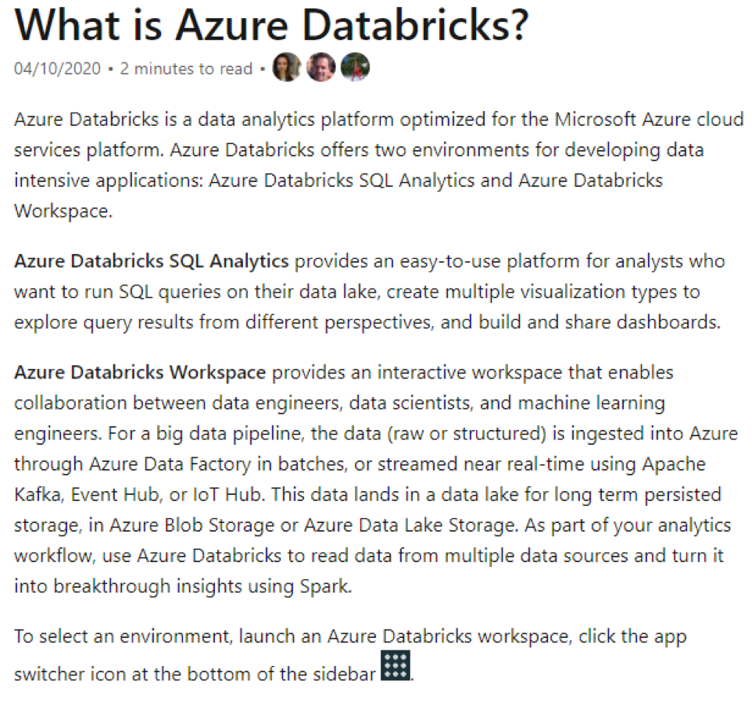

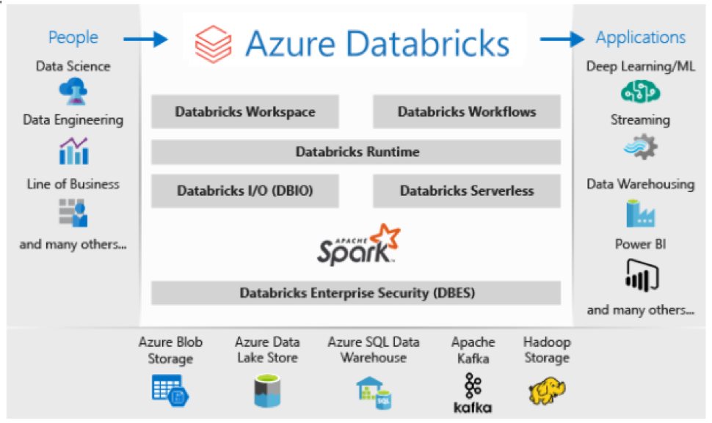

Bottom of Form

Top of Form

Question 12: **Correct**

Please evaluate the following statement and select **Yes** if the statement is true, otherwise select **No**.

You can use Azure Application Insights to detect and diagnose anomalies in web applications.

* ​

Yes

**(Correct)**

* ​

No

**Explanation**

Azure Application Insights, included in Azure Monitor, is a very powerful feature that you may want to be aware of. It can definitely help you identify functional anomalies that can take place in your web applications’ environment.

*“Application Insights, a feature of Azure Monitor, is an extensible Application Performance Management (APM) service for developers and DevOps professionals.*

*Use it to monitor your live applications. It will automatically detect performance anomalies, and includes powerful analytics tools to help you diagnose issues and to understand what users actually do with your app.” - microsoft.com*

**Reference:**

<https://docs.microsoft.com/en-us/azure/azure-monitor/app/app-insights-overview>

**Quick Preview:**

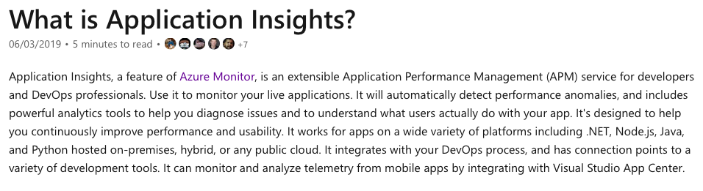

Bottom of Form

Top of Form

Question 13: **Correct**

You are working on a project in Azure and multiple departments from your company are involved.

Each department uses the same 30+ Azure resources on a daily basis. Your manager has asked you to implement a solution to automate the deployment of the Azure resources.

Which of the following options should you use?

* ​

Azure Resource Manager templates

**(Correct)**

* ​

virtual machine scale sets

* ​

the Azure API Management service

* ​

management groups

**Explanation**

Infrastructure as Code or simply IaC represents the managing and provisioning of infrastructure through code instead of through manual processes.

With IaC, configuration files are created that contain your infrastructure specifications, which makes it easier to edit and distribute configurations. It also ensures that you provision the same environment every time, and error free also.

In Azure, Azure Resource Manager templates can help you automate Azure resources deployment.

**Microsoft documentation states the following:**

*“To implement infrastructure as code for your Azure solutions, use Azure Resource Manager templates (ARM templates).*

*The template is a JavaScript Object Notation (JSON) file that defines the infrastructure and configuration for your project. The template uses declarative syntax, which lets you state what you intend to deploy without having to write the sequence of programming commands to create it.*

*In the template, you specify the resources to deploy and the properties for those resources.” - microsoft.com*

**Reference:**

<https://docs.microsoft.com/en-us/azure/azure-resource-manager/templates/overview>

**Quick Preview:**

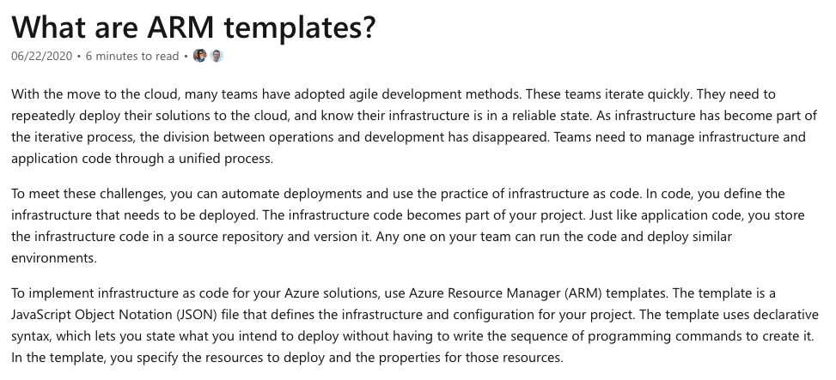

Bottom of Form

Top of Form

Question 14: **Correct**

*Note: This question is part of a series of questions that present the same scenario. Please read the scenario and evaluate if the solution presented meets the requirements.*

You have an Azure subscription named *AZ-900-Subscription*. You sign in to the Azure portal and create a resource group named *RG-AZ-900*.

You intend to use the following command that creates a virtual machine named *VirtualMachine01*:

**az vm create --resource-group RG-AZ-900 --name VirtualMachine01 --image UbuntuLTS --generate-ssh-keys**

You need to create *VirtualMachine01* in *AZ-900-Subscriptio*n by using the command.

**Solution: Launch Azure Cloud Shell in Azure Portal, select Bash and run the command in Cloud Shell.**

Does this meet the goal?

* ​

Yes

**(Correct)**

* ​

No

**Explanation**

Azure Cloud Shell is a very powerful tool available in Azure Portal. Within Azure Cloud Shell, you can choose either Bash or PowerShell to configure or manage your Azure subscription.

Very important to note and understand is that in order to access Azure Cloud Shell (Bash or PowerShell), you only need a valid internet connection to connect to Azure Portal. Once you connect and authenticate with Azure Portal, you can then launch Azure Cloud Shell, choose either Bash or PowerShell and deploy whatever Azure services you want or need.

The command presented is technically correct, you only need to validate where exactly you can run this command. The command is Azure CLI specific, so you can run it either in Bash, in Azure Cloud Shell, or maybe locally on your laptop or PC, if you have all necessary prerequisites installed.

**Microsoft documentation states the following:**

“*1. Start Azure Cloud Shell*- *Launch****Cloud Shell****from the top navigation of the Azure portal.*

*2. Select either Bash or PowerShell environment*

*3. Run Bash or PowerShell commands in the Azure Cloud Shell console ” - microsoft.com*

**Reference:**

<https://docs.microsoft.com/en-us/azure/virtual-machines/linux/quick-create-cli>

Cloud shell introduction :

<https://docs.microsoft.com/en-us/azure/cloud-shell/overview>

**Quick Preview:**

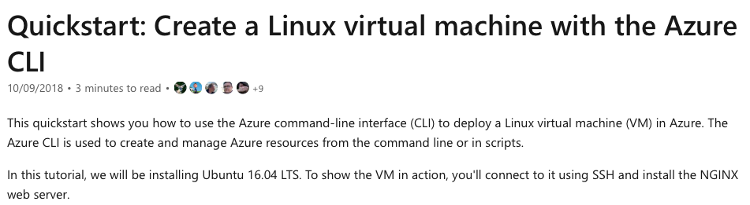

Bottom of Form

Top of Form

Question 15: **Incorrect**

*Note: This question is part of a series of questions that present the same scenario. Please read the scenario and evaluate if the solution presented meets the requirements.*

You have an Azure subscription named *AZ-900-Subscription*. You sign in to the Azure portal and create a resource group named *RG-AZ-900*.

You intend to use the following command that creates a virtual machine named *VirtualMachine01*.

**az vm create --resource-group RG-AZ-900 --name VirtualMachine01 --image UbuntuLTS --generate-ssh-keys**

You need to create *VirtualMachine01* in *AZ-900-Subscriptio*n by using the command.

**Solution: Launch Azure Cloud Shell from Azure Portal, select PowerShell and run the command in Cloud Shell.**

Does this meet the goal?

* ​

Yes

**(Correct)**

* ​

No

**(Incorrect)**

**Explanation**

Azure Cloud Shell is a very powerful tool available in Azure Portal. Within Azure Cloud Shell, you can choose either Bash or PowerShell to configure or manage your Azure subscription.

Very important to note and understand is that in order to access Azure Cloud Shell (Bash or PowerShell), you only need a valid internet connection to connect to Azure Portal. Once you connect and authenticate with Azure Portal, you can then launch Azure Cloud Shell, choose either Bash or PowerShell and deploy whatever Azure services you want or need.

The command presented is technically correct, you only need to validate where exactly you can run this command. The command is Azure CLI specific, so you can run it either in Bash, in Azure Cloud Shell, or maybe locally on your laptop or PC, if you have all necessary prerequisites installed.

Although the presented command is Azure CLI specific, it will run in PowerShell as well. This is simply because Azure has implemented this functionality, but again, the command is Azure CLI specific.

**Microsoft documentation states the following:**

“*1. Start Azure Cloud Shell*- *Launch****Cloud Shell****from the top navigation of the Azure portal.*

*2. Select either Bash or PowerShell environment*

*3. Run Bash or PowerShell commands in the Azure Cloud Shell console ” - microsoft.com*

**Reference:**

<https://docs.microsoft.com/en-us/azure/virtual-machines/linux/quick-create-cli>

Cloud Shell Introduction: <https://docs.microsoft.com/en-us/azure/cloud-shell/overview>

PowerShell Az Module: <https://docs.microsoft.com/en-us/powershell/azure/new-azureps-module-az>

**Quick Preview:**



Bottom of Form

Top of Form

Question 16: **Correct**

*Note: This question is part of a series of questions that present the same scenario. Please read the scenario and evaluate if the solution presented meets the requirements.*

You have an Azure subscription named *AZ-900-Subscription*. You sign in to the Azure portal and create a resource group named *RG-AZ-900*.

You intend to use the following command that creates a virtual machine named *VirtualMachine01*.

**az vm create --resource-group RG-AZ-900 --name VirtualMachine01 --image UbuntuLTS --generate-ssh-keys**

You need to create *VirtualMachine01* in *AZ-900-Subscriptio*n by using the command.

**Solution: Install Azure CLI on your Windows 10 laptop, open PowerShell app, sign in to Azure and run the command.**

Does this meet the goal?

* ​

Yes

**(Correct)**

* ​

No

**Explanation**

If you don’t want to use Azure Cloud Shell and prefer working on your own laptop, you first need to install Azure CLI module on your laptop or PC.

Once this process is complete, you can start running commands directly on your laptop, either in Command Prompt application or PowerShell application.

Since the proposed solution mentions installing the CLI module in the first place, and then running the command, the proposed solution will technically meet the goal.

**Microsoft documentation states the following:**

*“For Windows, the Azure CLI is installed via a MSI, which gives you access to the CLI through the Windows Command Prompt (CMD) or PowerShell.*

*You can now run the Azure CLI with the****az****command from either Windows Command Prompt or PowerShell.” - microsoft.com*

**Reference:**

<https://docs.microsoft.com/en-us/cli/azure/install-azure-cli-windows?view=azure-cli-latest&tabs=azure-cli>

**Quick Preview:**

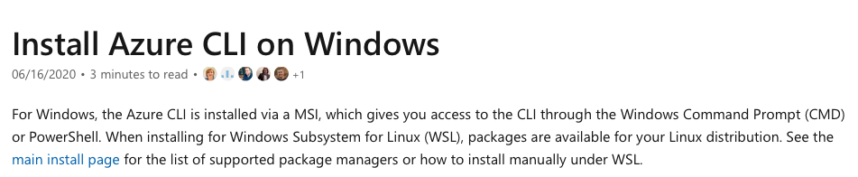

Bottom of Form

Top of Form

Question 17: **Incorrect**

*Note: This question is part of a series of questions that present the same scenario. Please read the scenario and evaluate if the solution presented meets the requirements.*

You have an Azure subscription named *AZ-900-Subscription*. You sign in to the Azure portal and create a resource group named *RG-AZ-900*.

You intend to use the following command that creates a virtual machine named *VirtualMachine01*.

**az vm create --resource-group RG-AZ-900 --name VirtualMachine01 --image UbuntuLTS --generate-ssh-keys**

You need to create *VirtualMachine01* in *AZ-900-Subscriptio*n by using the command.

**Solution: Install Azure CLI on your Windows 10 laptop, open Command Prompt, sign in to Azure and then run the command.**

Does this meet the goal?

* ​

Yes

**(Correct)**

* ​

No

**(Incorrect)**

**Explanation**

If you don’t want to use Azure Cloud Shell and prefer working on your own laptop, you first need to install Azure CLI module on your laptop or PC.

Once this process is complete, you can start running commands directly on your laptop, either in Command Prompt application or PowerShell application.

Since the proposed solution mentions installing the CLI module in the first place, and then running the command, the proposed solution will technically meet the goal.

**Microsoft documentation states the following:**

*“For Windows, the Azure CLI is installed via a MSI, which gives you access to the CLI through the Windows Command Prompt (CMD) or PowerShell.*

*You can now run the Azure CLI with the az command from either Windows Command Prompt or PowerShell.” - microsoft.com*

**Reference:**

<https://docs.microsoft.com/en-us/cli/azure/install-azure-cli-windows?view=azure-cli-latest>

**Quick Preview:**



Bottom of Form

Top of Form

Question 18: **Correct**

Which of the following Azure services represents serverless computing in Azure ?

* ​

Azure Virtual Machines

* ​

Azure Functions

**(Correct)**

* ​

Azure Storage Account

* ​

Azure Container Instances

**Explanation**

Azure provides a range of serverless execution environments, fully managed services and a comprehensive set of developer tools and services to build your applications.

If we now refer to running code in Azure in a serverless manner, Azure Functions service can be used. Both containers and virtual machines represent Azure computing options, that you will pay for by renting compute power.

Azure Storage Account doesn’t meet the requirements as well, because Storage Accounts represent a combination of IaaS – Infrastructure as a Service and PaaS – Platform as a Service.

**Microsoft documentation states the following:**

*“Azure Functions is a serverless solution that allows you to write less code, maintain less infrastructure, and save on costs. Instead of worrying about deploying and maintaining servers, the cloud infrastructure provides all the up-to-date resources needed to keep your applications running.*

*You focus on the pieces of code that matter most to you, and Azure Functions handles the rest.” - microsoft.com*

**Reference:**

<https://docs.microsoft.com/en-us/azure/azure-functions/functions-overview>

**Quick Preview:**

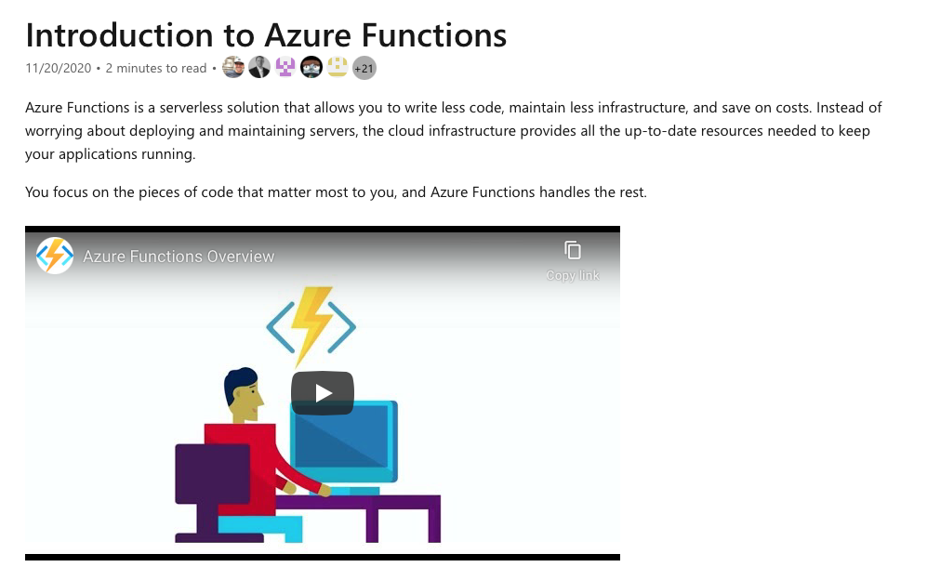

Bottom of Form

Top of Form

Question 19: **Incorrect**

Please evaluate the following statement and select **Yes** if the statement is true, otherwise select **No**.

Azure virtual machines provide operating system virtualization.

* ​

Yes

**(Incorrect)**

* ​

No

**(Correct)**

**Explanation**

Azure virtual machines provide hardware virtualization.

**Microsoft documentation states the following:**

*“Azure Virtual Machines (VM) is one of several types of on-demand, scalable computing resources that Azure offers.*

*Typically, you choose a VM when you need more control over the computing environment than the other choices offered.” - microsoft.com*

**Reference:**

<https://docs.microsoft.com/en-us/azure/virtual-machines/windows/overview>

**Quick Preview:**

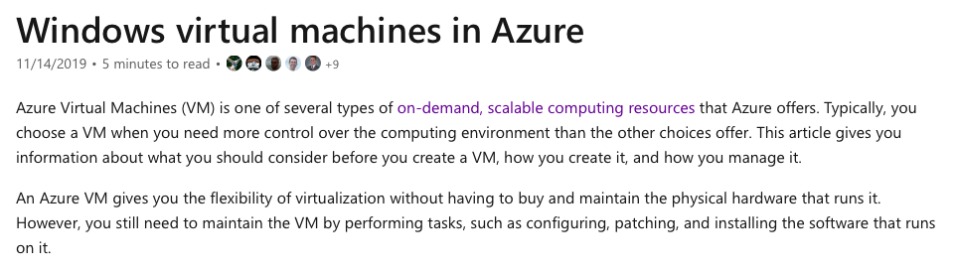

Bottom of Form

Top of Form

Question 20: **Correct**

Please evaluate the following statement and select **Yes** if the statement is true, otherwise select **No**.

Azure Container Instances provides a portable environment for virtualized applications.

* ​

Yes

**(Correct)**

* ​

No

**Explanation**

Azure Container Instances service is the Azure service that you can use to run individual containers. It’s a great solution when you need to run just a few containers.

Moving forward, if you need to run tens, hundreds or even thousands of containers, you may want to consider using AKS – Azure Kubernetes Service. AKS is great because you can orchestrate the deployment, update and management processes for all your containers.

Last, but not least, using containers is great because you gain portability. What I mean by this is that you don’t get stuck on using a platform for your application. If you want to, while using containers, you can simply and easily migrate your application to a different platform or hosting environment (other data center, either private or public cloud offering).

**Microsoft documentation states the following:**

*“Containers are becoming the preferred way to package, deploy, and manage cloud applications. Azure Container Instances offers the fastest and simplest way to run a container in Azure, without having to manage any virtual machines and without having to adopt a higher-level service.*

*Containers offer significant startup benefits over virtual machines (VMs). Azure Container Instances can start containers in Azure in seconds, without the need to provision and manage VMs.” - microsoft.com*

**Reference:**

<https://docs.microsoft.com/en-us/azure/container-instances/container-instances-overview>

**Quick Preview:**

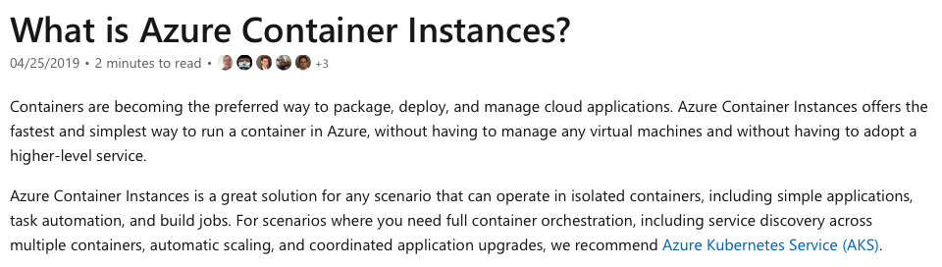

Bottom of Form

Top of Form

Question 21: **Correct**

Please evaluate the following statement and select **Yes** if the statement is true, otherwise select **No**.

Azure App Service is an Azure service that you can use to build, deploy and scale web apps.

* ​

Yes

**(Correct)**

* ​

No

**Explanation**

The statement is definitely true. You can use Azure App Service to deploy and automatically scale your web apps in Azure.

**Microsoft documentation states the following:**

*“Azure App Service is an HTTP-based service for hosting web applications, REST APIs, and mobile back ends. You can develop in your favorite language, be it .NET, .NET Core, Java, Ruby, Node.js, PHP, or Python.*

*Applications run and scale with ease on both Windows and Linux-based environments.” - microsoft.com*

**Reference:**

<https://docs.microsoft.com/en-us/azure/app-service/overview>

**Quick Preview:**

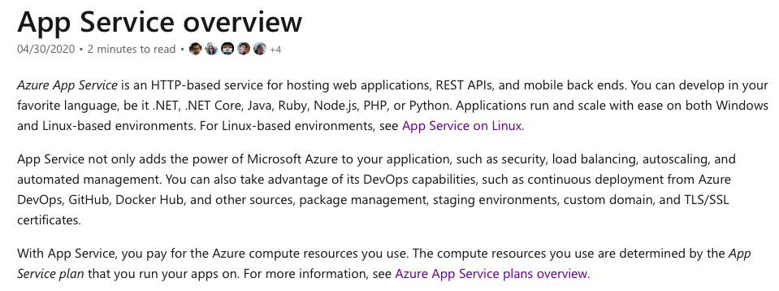

Bottom of Form

Top of Form

Question 22: **Correct**

Please evaluate the following statement and select **Yes** if the statement is true, otherwise select **No**.

In order to encrypt all traffic sent from Azure data centers to any outside destinations, you can use Azure Firewall service.

* ​

Yes

* ​

No

**(Correct)**

**Explanation**

Azure Firewall service can’t be used to encrypt any kind of network traffic. Azure Firewall is security service that you can use to protect your resources deployed inside an Azure Virtual Network.

**Microsoft documentation states the following:**

*“Azure Firewall is a managed, cloud-based network security service that protects your Azure Virtual Network resources. It's a fully stateful firewall as a service with built-in high availability and unrestricted cloud scalability.*

*You can centrally create, enforce, and log application and network connectivity policies across subscriptions and virtual networks.” - microsoft.com*

**Reference:**

<https://docs.microsoft.com/en-us/azure/firewall/overview>

**Quick Preview:**

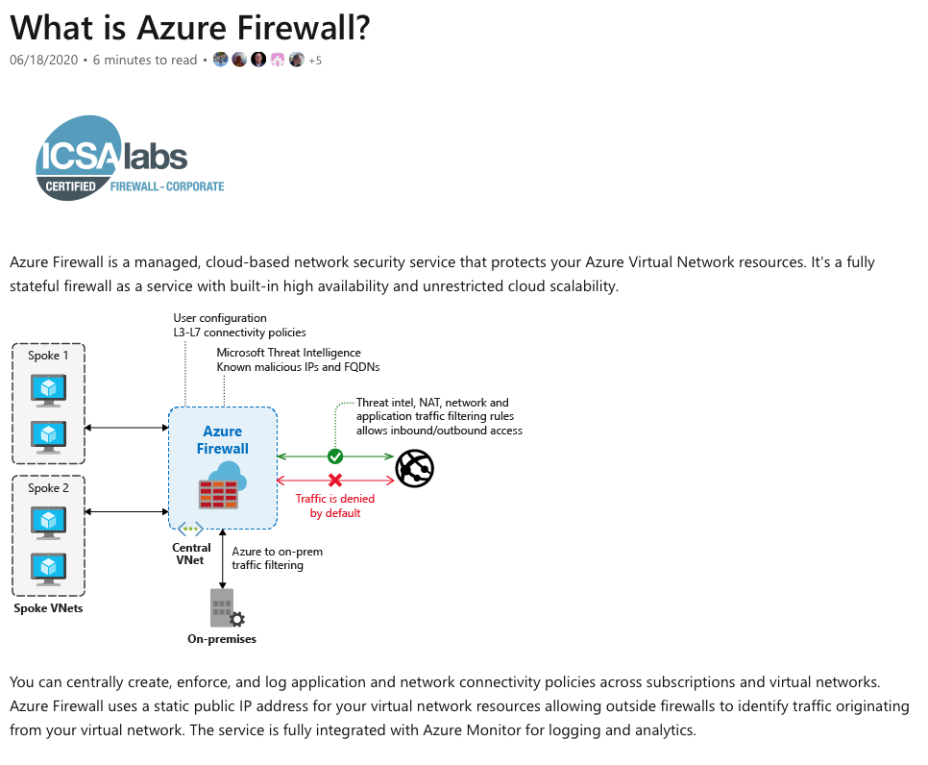

Bottom of Form

Top of Form

Question 23: **Correct**

Please evaluate the following statement and select **Yes** if the statement is true, otherwise select **No**.

In order to encrypt all traffic sent from Azure data centers to any outside destinations, you can use Azure Network Security Groups (NSGs).​

* ​

Yes

* ​

No

**(Correct)**

**Explanation**

Azure Network Security Groups can’t be used to encrypt any kind of network traffic. The main use case for Azure network security groups is traffic filtering.

What kind of traffic ? Well, traffic going into Azure data centers, or traffic leaving Azure data centers.

Where are network security groups applied? NSGs are applied either at the VM level (specifically at the network interface card level), or at the subnet level. If you want or need to apply traffic filtering policies at the virtual network level, you can use the Azure Firewall service.

**Microsoft documentation states the following:**

*“You can use an Azure network security group to filter network traffic to and from Azure resources in an Azure virtual network. A network security group contains security rules that allow or deny inbound network traffic to, or outbound network traffic from, several types of Azure resources. For each rule, you can specify source and destination, port, and protocol.” - microsoft.com*

**Reference:**

<https://docs.microsoft.com/en-us/azure/virtual-network/security-overview>

**Quick Preview:**

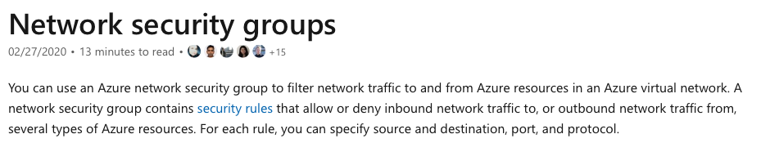

Bottom of Form

Top of Form

Question 24: **Incorrect**

Please evaluate the following statement and select **Yes** if the statement is true, otherwise select **No**.

All outbound traffic sent from Azure Windows server virtual machines is encrypted by default.

* ​

Yes

**(Incorrect)**

* ​

No

**(Correct)**

**Explanation**

The question is rather vague as it would depend on the configuration of the host on the Internet. Windows Server does come with a VPN client and it also supports other encryption methods such IPSec encryption or SSL/TLS, so it could encrypt the traffic if the Internet host was configured to require or accept the encryption.

However, the VM could not encrypt the traffic to an Internet host that is not configured to require the encryption. Anyway, some configuration needs to be done, outbound traffic encryption doesn't happen by default.

**Reference:**

<https://docs.microsoft.com/en-us/azure/security/fundamentals/data-encryption-best-practices#protect-data-in-transitQUESTION>

**Quick Preview:**

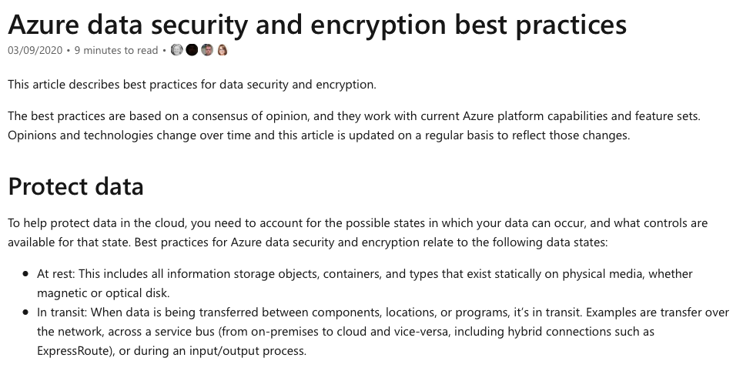

Bottom of Form

Top of Form

Question 25: **Incorrect**

You are currently working in an Azure virtual network named *AZ-900-VNET* in a resource group named *AZ-900-RG*.

You receive an email from your manager and you assign an Azure policy specifying that virtual networks are not an allowed resource type in *AZ-900-RG*.

What happens with your *AZ-900-VNET ?*

* ​

*AZ-900-VNET*is deleted automatically

* ​

*AZ-900-VNET*is moved automatically to another resource group

* ​

*AZ-900-VNET*continues to function normally

**(Correct)**

* ​

*AZ-900-VNET*has now a read-only lock applied

**(Incorrect)**

**Explanation**

After applying the policy to your AZ-900-RG, the *AZ-900-VNET* will be marked as "Non-compliant". This means that this resource group is not compliant with the applied policy. The key point to understand is that, for example, you will not be allowed to deploy new virtual networks inside AZ-900-RG resource group, but existing resources will continue to function normally.

Simply put, Azure Policy effects are not retroactive, they count only for new resources that you may want to deploy.

**Microsoft documentation states the following:**

*“Azure Policy helps to enforce organizational standards and to assess compliance at-scale.*

*Resources are evaluated at specific times during the resource lifecycle, the policy assignment lifecycle, and for regular ongoing compliance evaluation.*

*Remediate non-compliant resources - While these effects primarily affect a resource when the resource is created or updated, Azure Policy also supports dealing with existing non-compliant resources without needing to alter that resource.” - microsoft.com*

**References:**

<https://docs.microsoft.com/en-us/azure/governance/policy/overview>

<https://docs.microsoft.com/en-us/azure/governance/policy/assign-policy-portal>

**Quick Preview:**

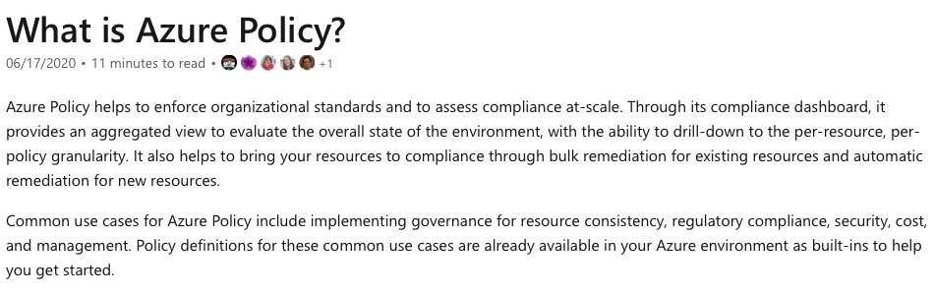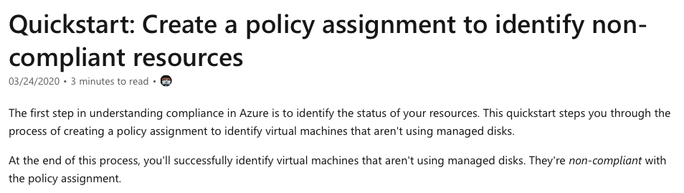

Bottom of Form

Top of Form

Question 26: **Correct**

Your manager has asked you to investigate a security event. It seems that a VM running a production application has been intentionally turned off by a user in the past 30 days.

What Azure service can help you during your investigation?

* ​

Azure Monitor

* ​

Azure Event Hubs

* ​

Azure Activity Log

**(Correct)**

* ​

Azure Service Health

**Explanation**

The Azure official documentation is pretty clear on this topic.

**Microsoft documentation states the following:**

*“Through activity logs, you can determine:*

- *what operations were taken on the resources in your subscription*

- *who started the operation*

- *when the operation occurred*

- *the status of the operation*

- *the values of other properties that might help you research the operation” - microsoft.com*

For this reason, the best option to choose for this specific scenario is Azure Activity Log, included in Azure Monitor service.

**Microsoft documentation states the following:**

*“Activity logs are kept for 90 days. You can query for any range of dates, as long as the starting date isn't more than 90 days in the past.” - microsoft.com*

**During your investigation, you would need to create a filter to display any shutdown operations performed on the virtual machine, in the last 30 days.**

**Reference:**

<https://docs.microsoft.com/en-us/azure/azure-resource-manager/management/view-activity-logs>

**Quick Preview:**

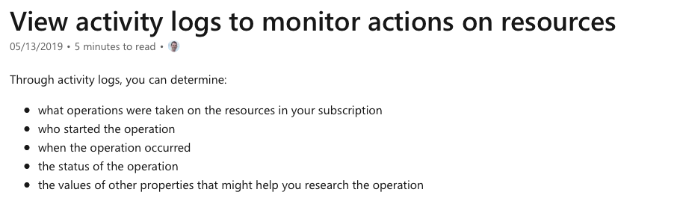

Bottom of Form

Top of Form

Question 27: **Incorrect**

Please evaluate the following statement and select **Yes** if the statement is true, otherwise select **No**.

While working in Azure portal, you can generate a list of Azure VMs that are protected by Azure Backup using Azure Advisor service.

* ​

Yes

**(Incorrect)**

* ​

No

**(Correct)**

**Explanation**

Azure Advisor is a powerful tool that can help you optimize your Azure environment. Also, Azure Advisor provides guidance and recommendations than can help you follow current best practices.

**Microsoft documentation states the following:**

*“With Advisor, you can:*

- *Get proactive, actionable, and personalized best practices recommendations.*

- *Improve the performance, security, and reliability of your resources, as you identify opportunities to reduce your overall Azure spend.*

- *Get recommendations with proposed actions inline.”*

Back in 2017, Azure announced and launched a new functionality within Azure Advisor.

*“With this announcement, Azure Advisor provides recommendations on virtual machines that are not backed up and will let you enable backup on those virtual machines with just a few clicks.” - microsoft.com*

With that said, it’s clear now that Azure Advisor can generate a list of VMs that are not backed up and, since this scenario is asking for a list of VMs that are protected, than the presented statement is false.

**Reference:**

Azure Advisor Overview: <https://docs.microsoft.com/en-us/azure/advisor/advisor-overview>

<https://azure.microsoft.com/en-gb/blog/advisor-backup-recommendations/>

**Quick Preview:**

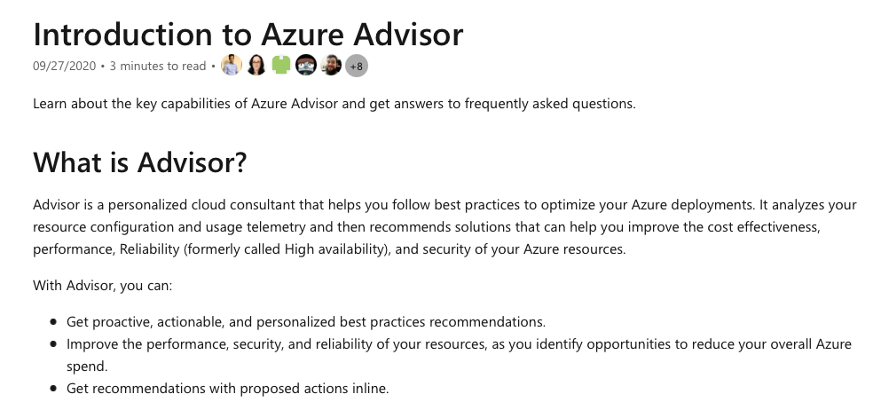

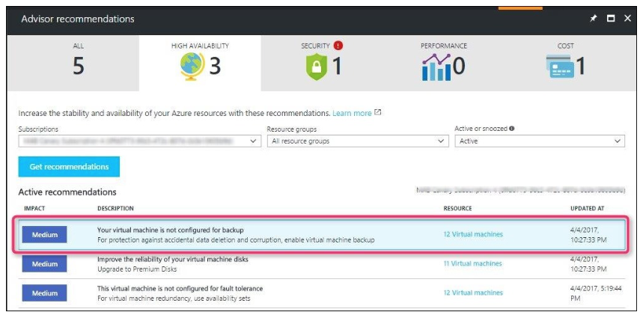

Bottom of Form

Top of Form

Question 28: **Correct**

Please evaluate the following statement and select **Yes** if the statement is true, otherwise select **No**.

Your company’s secure score will decrease if you implement the security recommendations provided by Azure Advisor.

* ​

Yes

* ​

No

**(Correct)**

**Explanation**

Well, it’s actually the other way around, so the statement is false.

**Microsoft documentation states the following:**

*“Azure Advisor provides you with a consistent, consolidated view of recommendations for all your Azure resources. It integrates with Azure Security Center to bring you security recommendations. You can get security recommendations from the Security tab on the Advisor dashboard.”*

If you implement security recommendations provided by Azure Advisor, your company’s secure score will increase, and not decrease.

**Microsoft documentation states the following:**

*“To increase your security, review Security Center's recommendations page for the outstanding actions necessary to raise your score. Each recommendation includes instructions to help you remediate the specific issue.”*

**Reference:**

<https://docs.microsoft.com/en-us/azure/advisor/advisor-security-recommendations>

**Quick Preview:**

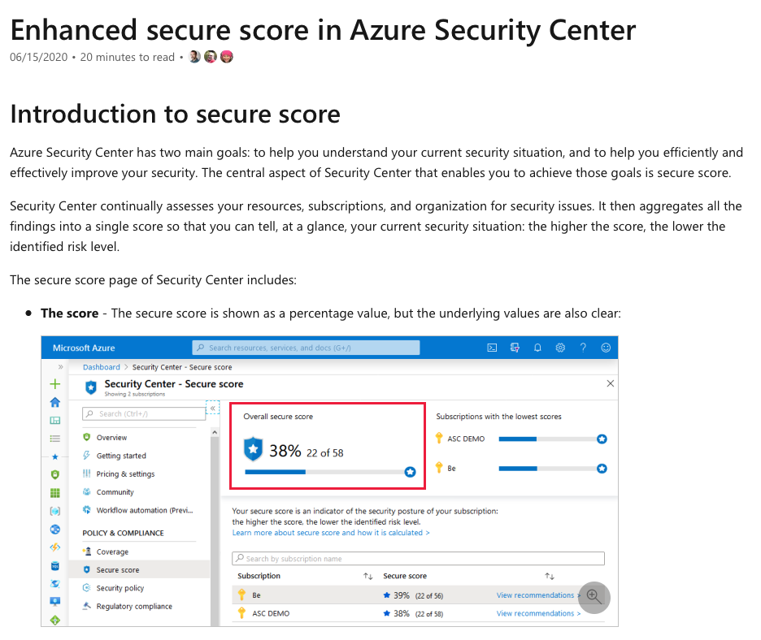

Bottom of Form

Top of Form

Question 29: **Incorrect**

Please evaluate the following statement and select **Yes** if the statement is true, otherwise select **No**.

Security recommendations provided by Azure Advisor must be implemented in maximum 7 days.

* ​

Yes

**(Incorrect)**

* ​

No

**(Correct)**

**Explanation**

Actually, the statement is false. The key point here is the difference between a recommendation and a requirement.

You don’t have to implement any recommendation if you don’t want to, recommendations are generated in order to help and guide you to better secure your overall Azure environment.

**Reference:**

<https://docs.microsoft.com/en-us/azure/advisor/advisor-overview>

<https://docs.microsoft.com/en-us/azure/advisor/advisor-security-recommendations>

**Quick Preview:**

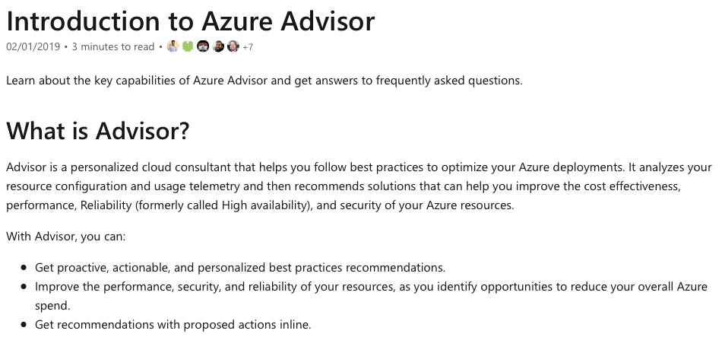

Bottom of Form

Top of Form

Question 30: **Correct**

Which of the following statements best describes the Modern Lifecycle Policy related to Azure services?

* ​

By default, Microsoft provides support for a service for 5 years.

* ​

Before ending support for a service, Microsoft provides a minimum of 12 months’ notice.

**(Correct)**

* ​

Once a new service reaches general availability phase, Microsoft provides support for the service for a minimum of 4 years.

* ​

Microsoft allows purchasing extended support for its service for up to 5 years.

**Explanation**

Before ending support for a service, Microsoft provides a minimum of 12 months’ notice.

**Microsoft documentation states the following:**

*“For products governed by the Modern Lifecycle Policy, Microsoft will provide a minimum of 12 months' notification prior to ending support if no successor product or service is offered—excluding free services or preview releases.” - microsoft.com*

**Reference:**

<https://docs.microsoft.com/en-us/lifecycle/policies/modern>

**Quick Preview:**

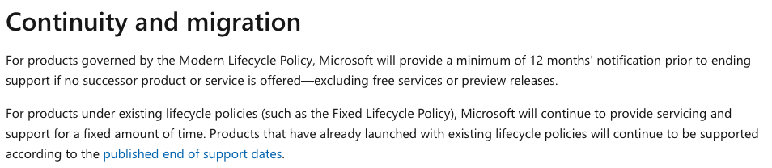

Bottom of Form

Top of Form

Question 31: **Correct**

Please evaluate the following statement and select **Yes** if the statement is true, otherwise select **No**.

Azure SLAs guarantee a minimum uptime of 99.9% for vast majority of Azure paid services.

* ​

Yes

**(Correct)**

* ​

No

**Explanation**

Relevant information related to SLA – Service Level Agreement is presented in the official documentation URL below.

Simply put, the minimum guaranteed uptime for the vast majority of Azure services is 99.9%, which means that the statement is indeed true. In general, the SLA uptime increases if you deploy resources in multiple Azure availability zones or Azure regions.

Here’s an example related to Azure virtual machines SLA.

*“For any Single Instance Virtual Machine using Premium SSD or Ultra Disk for all Operating System Disks and Data Disks, we guarantee you will have Virtual Machine Connectivity of at least 99.9%.*

*For all Virtual Machines that have two or more instances deployed across two or more Availability Zones in the same Azure region, we guarantee you will have Virtual Machine Connectivity to at least one instance at least 99.99% of the time.” - microsoft.com*

**Reference:**

<https://azure.microsoft.com/en-us/support/legal/sla/summary/>

**Quick Preview:**

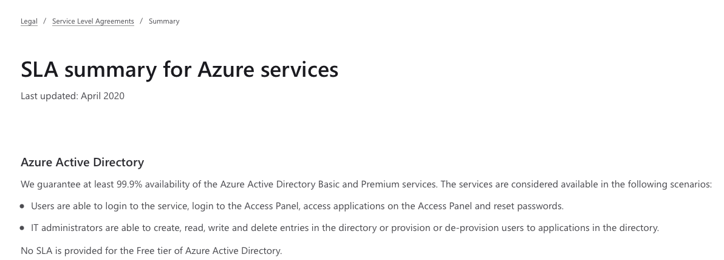

Bottom of Form

Top of Form

Question 32: **Incorrect**

Please evaluate the following statement and select **Yes** if the statement is true, otherwise select **No**.

If you add Azure resources to multiple regions , the Azure Service Level Agreement (SLA) guaranteed uptime will increase. ​

* ​

Yes

**(Correct)**

* ​

No

**(Incorrect)**

**Explanation**

Relevant information related to SLA – Service Level Agreement is presented in the official documentation URL below.

Simply put, the minimum guaranteed uptime for the vast majority of Azure services is 99.9%, which will increase if you add Azure resources to multiple Azure availability zones or regions.

Here’s an example related to Azure virtual machines SLA.

**Microsoft documentation states the following:**

*“For any Single Instance Virtual Machine using Premium SSD or Ultra Disk for all Operating System Disks and Data Disks, we guarantee you will have Virtual Machine Connectivity of at least 99.9%.*

*For all Virtual Machines that have two or more instances deployed across two or more Availability Zones in the same Azure region, we guarantee you will have Virtual Machine Connectivity to at least one instance at least 99.99% of the time.”*

As the Microsoft official documentation highlights, in this specific example the guaranteed uptime SLA will increase from 99.9%, when deploying an app to a single VM, to 99.99% when deploying an app to two or more VMs, deployed in two or more availability zones.

The same is true if you deploy an app to two or more regions, because an Azure region contains multiple availability zones.

**Reference:**

<https://azure.microsoft.com/en-us/support/legal/sla/summary/>

**Quick Preview:**

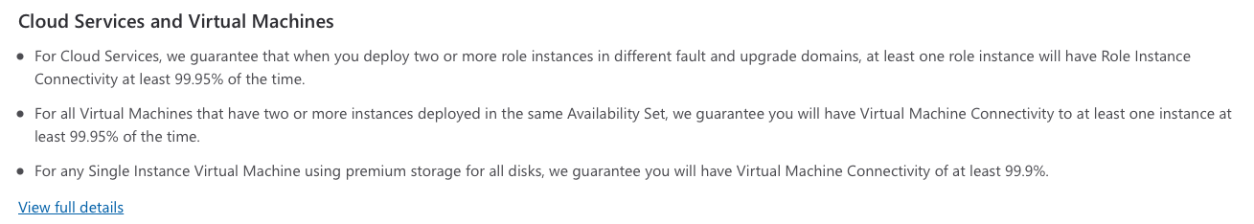

Bottom of Form

Top of Form

Question 33: **Correct**

You have received a new task to increase the Service Level Agreement (SLA) guaranteed uptime for App1 that is running in Azure.

Please evaluate the following statement and select **Yes** if the statement is true, otherwise select **No**.

App1 SLA guaranteed uptime will increase if you purchase multiple Azure subscriptions.

* ​

Yes

* ​

No

**(Correct)**

**Explanation**

While working in Azure, you could be running your applications inside a single subscription or by running multiple subscriptions.

Azure Subscriptions are great if you need to segment your applications into different groups. For example, you could have a dedicated subscription per department or per environment type: production, development and testing.

However, the SLA for a specific product or solution is not connected in any way to the number of subscriptions that you are using. Microsoft Azure guarantees uptime for your applications or workloads that you are running based on other factors and not the number of subscriptions.

Here’s an example related to Azure virtual machines SLA.

**Microsoft documentation states the following:**

*“For any Single Instance Virtual Machine using Premium SSD or Ultra Disk for all Operating System Disks and Data Disks, we guarantee you will have Virtual Machine Connectivity of at least 99.9%.*

*For all Virtual Machines that have two or more instances deployed across two or more Availability Zones in the same Azure region, we guarantee you will have Virtual Machine Connectivity to at least one instance at least 99.99% of the time.”*

**Reference:**

<https://azure.microsoft.com/en-us/support/legal/sla/summary/>

**Quick Preview:**



Bottom of Form

Top of Form

Question 34: **Correct**

Your company is currently running three Azure subscriptions: Production, Development and Testing. Your manager has asked you to find a way to centrally manage all Azure subscriptions.

Please evaluate the following statement and select **Yes** if the statement is true, otherwise select **No**.

You can use your Microsoft account to manage all Azure subscriptions.

* ​

Yes

**(Correct)**

* ​

No

**Explanation**

When you sign up for an Azure account for the first time, you need to have a Microsoft account available. If you don’t have one already, then you need to create a Microsoft account.

Having a Microsoft account available will allow you to sign up for an Azure account, and an Azure subscription will be created for you. Depending on your needs, you can later on create and add multiple subscriptions under your Microsoft account.

As the scenario presents, enterprises usually decide to have a dedicated subscription per environment type: production, development and testing. Or you may find dedicated subscriptions per company department: IT, marketing, management, etc.

And yes, you manage all your subscriptions from the same Microsoft account.

**Reference:**

<https://docs.microsoft.com/en-us/azure/cost-management-billing/manage/create-subscription>

**Quick Preview:**

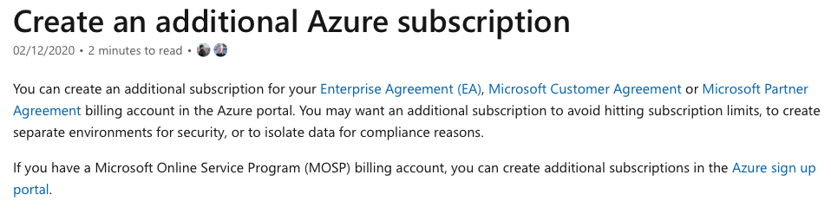

Bottom of Form

Top of Form

Question 35: **Incorrect**

Your company is currently running two Azure subscriptions: Production and Production_2.0. Your manager has asked you to find a way to merge the two subscriptions into a single subscription.

Please evaluate the second statement and select **Yes** if the statement is true, otherwise select **No**.

You can merge Production and Production_2.0 subscriptions into a single subscription by opening an Azure service request.

* ​

Yes

**(Incorrect)**

* ​

No

**(Correct)**

**Explanation**

Merging or combining two or multiple Azure subscriptions into a single subscription is simply not possible.

For this specific scenario, what you could do is migrate all resources deployed in one subscription to the other subscription. This way, you could be running all your resources inside a single subscription, but again merging or combining subscriptions into a single one is not possible.

**Reference:**

<https://docs.microsoft.com/en-us/azure/cost-management-billing/manage/create-subscription>

<https://docs.microsoft.com/en-us/azure/cost-management-billing/understand/subscription-transfer>

**Quick Preview:**



Bottom of Form

Top of Form

Question 36: **Correct**

Please evaluate the statement and select **Yes** if the statement is true, otherwise select **No**.

Azure customers are not limited to using one single subscription, customers can register and use multiple Azure subscriptions.

* ​

Yes

**(Correct)**

* ​

No

**Explanation**

When you sign up for an Azure account for the first time, you need to have a Microsoft account available. If you don’t have one already, then you need to create a Microsoft account.

Having a Microsoft account available will allow you to sign up for an Azure account, and an Azure subscription will be created for you. Depending on your needs, you can later on create and add multiple subscriptions under your Microsoft account.

For example, enterprises usually decide to have a dedicated subscription per environment type: production, development and testing. Or you may find dedicated subscriptions per company department: IT, marketing, management, etc.

So yes, customers can register and use multiple Azure subscriptions.

**Reference:**

<https://docs.microsoft.com/en-us/azure/cost-management-billing/manage/create-subscription>

**Quick Preview:**



Bottom of Form

Top of Form

Question 37: **Correct**

Please evaluate the statement and select **Yes** if the statement is true, otherwise select **No**.

All Azure customers can use services in private preview.​

* ​

Yes

* ​

No

**(Correct)**

**Explanation**

The statement is definitely false.

Usually, when Microsoft releases a new service, the service is released in private preview phase. During private preview, Microsoft will invite a few customers to test the new service and provide feedback. Also during private preview phase, regular support services are not available.

When the service is mature and considered ready for production environments testin, Microsoft will transition the service to public preview phase. During this phase, any customer can run and test the service. As opposed to private preview, Microsoft teams will provide formal support services in this phase.

The last step is migrating the service to generally available (GA) phase. During public preview phase, there may be functionalities or features fixing as well, but once the service is transitioned to GA, the new service is considered stable and ready for real production workloads. Also, the service is covered by support via all official Microsoft support channels.

And now, coming back to the statement presented in this scenario, we can clearly state that private preview services are not available to all Azure customers.

**Reference:**

<https://azure.microsoft.com/en-gb/support/legal/preview-supplemental-terms/>

**Quick Preview:**

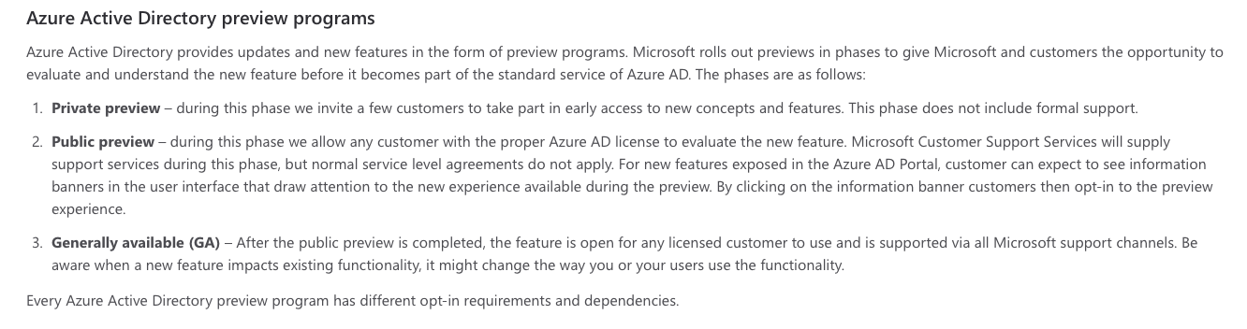

Bottom of Form

Top of Form

Question 38: **Correct**

Please evaluate the statement and select **Yes** if the statement is true, otherwise select **No**.

All Azure customers can use services in public preview.​

* ​

Yes

**(Correct)**

* ​

No

**Explanation**

The statement is definitely true.

Usually, when Microsoft releases a new service, the service is released in private preview phase. During private preview, Microsoft will invite a few customers to test the new service and provide feedback. Also during private preview phase, regular support services are not available.

When the service is mature and considered ready for production environments testin, Microsoft will transition the service to public preview phase. During this phase, any customer can run and test the service. As opposed to private preview, Microsoft teams will provide formal support services in this phase.

The last step is migrating the service to generally available (GA) phase. During public preview phase, there may be functionalities or features fixing as well, but once the service is transitioned to GA, the new service is considered stable and ready for real production workloads. Also, the service is covered by support via all official Microsoft support channels.

And now, coming back to the statement presented in this scenario, we can clearly state that public preview services are available to all Azure customers. Also, services in public preview phase are marked accordingly in the Azure portal, having a “Preview” label attached to the their name.

**Reference:**

<https://azure.microsoft.com/en-gb/support/legal/preview-supplemental-terms/>

**Quick Preview:**



Bottom of Form

Top of Form

Question 39: **Correct**

Your manager has asked you to check the health state of all Azure services running in your company environment.

Please evaluate if the following statement is **True** or **False**:

You can use Azure Service Health to accomplish this task.​

* ​

True

**(Correct)**

* ​

False

**Explanation**

When it comes to checking the health state of your resources running in Azure, Azure Service Health service is absolutely great. Azure Service Health actually includes three services: Azure Status, Service Health and Resource Health.

**Microsoft documentation states the following:**

*“****Azure Status****informs you of service outages in Azure on the Azure Status page.*

***Service health****provides a personalized view of the health of the Azure services and regions you're using.*

***Resource health****provides information about the health of your individual cloud resources such as a specific virtual machine instance.” - microsoft.com*

Coming back to this scenario, Service Health will provide you all the necessary details related to your services running in Azure. Also, when planned maintenance events are scheduled by Azure teams, and these activities will affect your resources running in Azure, you will be notified. This way you have Full visibility over your infrastructure’s current state, but also on “what’s next”.

**Reference:**

<https://docs.microsoft.com/en-us/azure/service-health/overview>

<https://docs.microsoft.com/en-us/azure/service-health/service-health-overview>

**Quick Preview:**

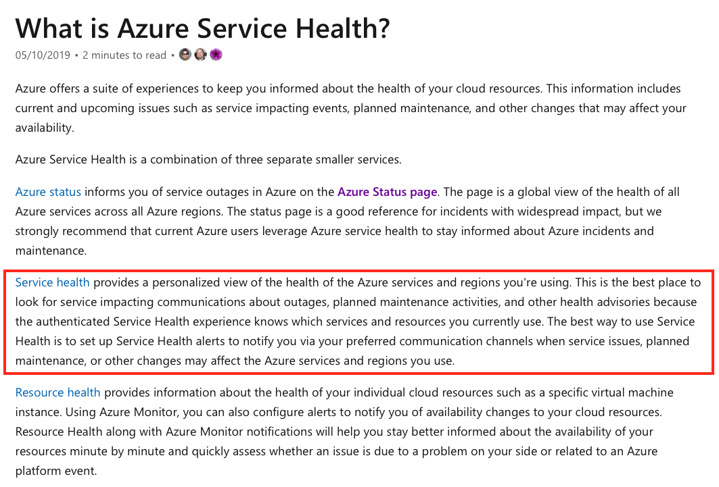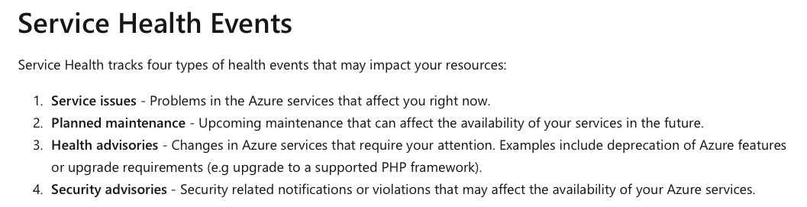

Bottom of Form

Top of Form

Question 40: **Correct**

Your manager wants to receive an alert if an Azure service fails.

Please evaluate if the following statement is **True** or **False**:

You can use Azure Service Health to accomplish this task.​

* ​

True

**(Correct)**

* ​

False

**Explanation**

Azure Service Health actually includes three services: Azure Status, Service Health and Resource Health.

**Microsoft documentation states the following:**

*“****Azure Status****informs you of service outages in Azure on the Azure Status page.*

***Service health****provides a personalized view of the health of the Azure services and regions you're using.*

***Resource health****provides information about the health of your individual cloud resources such as a specific virtual machine instance.”*

Azure Service Health can definitely help you to accomplish this task. You can simply create a service health alert, while using Azure portal, and receive notifications when there are any status changes related to your services in Azure.

Simply put, you will receive notifications or alerts when there are service issues, when planned maintenance events take place or anything else happens that may affect your service running in Azure.

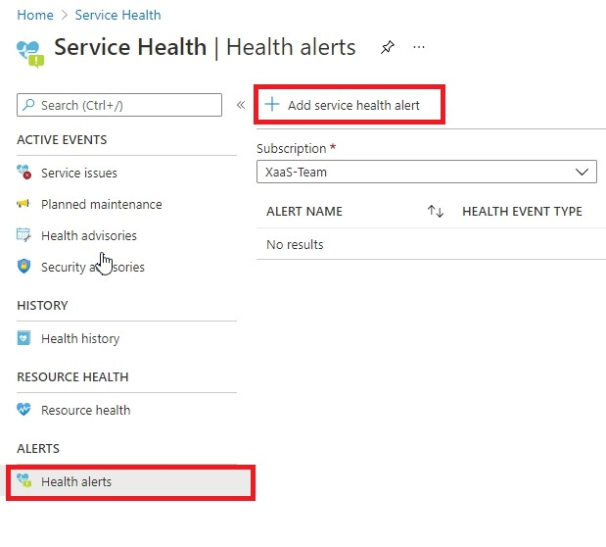

**Reference:**

<https://docs.microsoft.com/en-us/azure/service-health/overview>

**Quick Preview:**

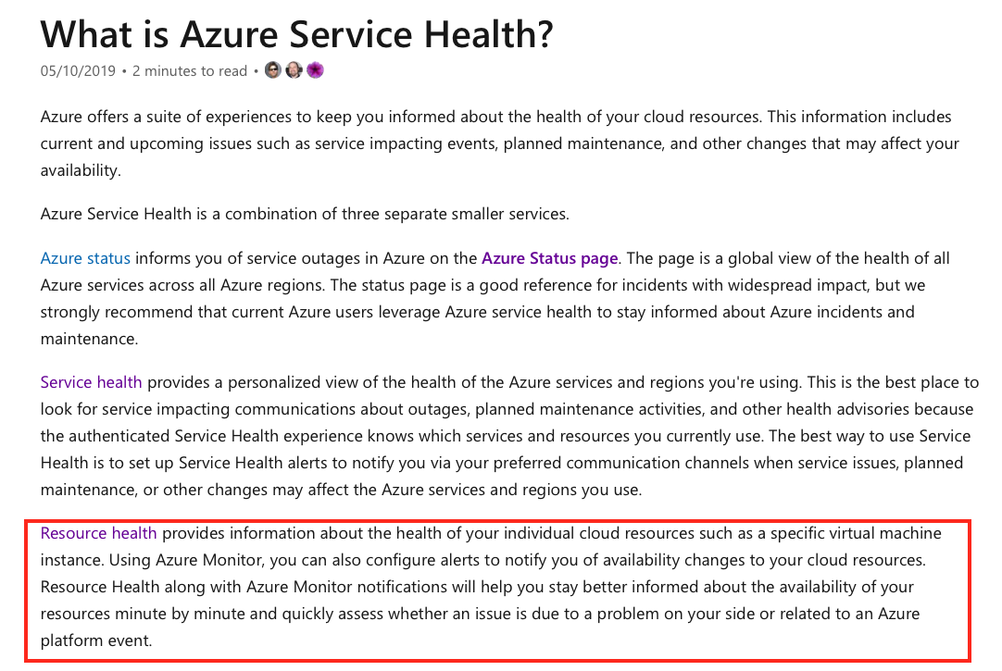

Bottom of Form

Top of Form

Question 41: **Incorrect**

Please evaluate if the following statement is **True** or **False**.

You can improve your Azure Active Directory (Azure AD) security if you follow Azure Advisor recommendations.

* ​

True

**(Incorrect)**

* ​

False

**(Correct)**

**Explanation**

**Microsoft documentation states the following:**

*“Advisor is a personalized cloud consultant that helps you follow best practices to optimize your Azure deployments.*

*The Advisor dashboard displays personalized recommendations for all your subscriptions. You can apply filters to display recommendations for specific subscriptions and resource types.” - microsoft.com*

However, Azure Advisor doesn't include recommendations targeting Azure Active Directory (Azure AD).

Azure Advisor provides recommendations and these are split into the following five categories:

**Reliability (formerly called High Availability)**: *“To ensure and improve the continuity of your business-critical applications.” (microsoft.com)*

**Security**: *“To detect threats and vulnerabilities that might lead to security breaches.”* *(microsoft.com)*

**Performance**: *“To improve the speed of your applications.” (microsoft.com)*

**Cost**: *“To optimize and reduce your overall Azure spending.” (microsoft.com)*

**Operational Excellence**: *“To help you achieve process and workflow efficiency, resource manageability and deployment best practices.” (microsoft.com)*

**Reference:**

<https://docs.microsoft.com/en-us/azure/advisor/advisor-overview>

**Quick Preview:**

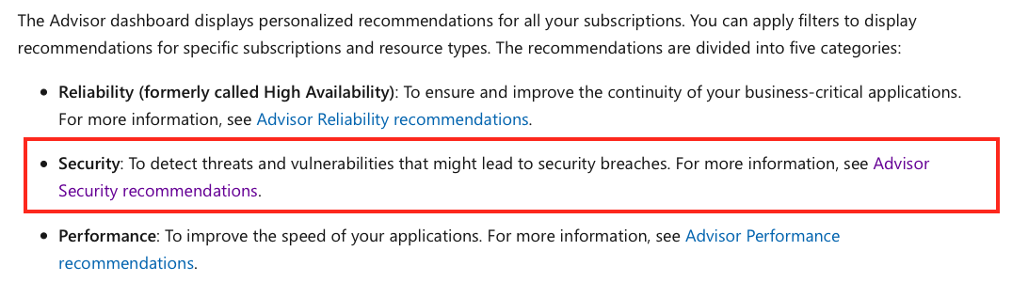

Bottom of Form

Top of Form

Question 42: **Correct**

Please evaluate if the following statement is **True** or **False**.

You can reduce the cost of your virtual machines running in Azure by following Azure Advisor recommendations.​

* ​

True

**(Correct)**

* ​

False

**Explanation**

**Microsoft documentation states the following:**

*“Advisor is a personalized cloud consultant that helps you follow best practices to optimize your Azure deployments.*

*The Advisor dashboard displays personalized recommendations for all your subscriptions. You can apply filters to display recommendations for specific subscriptions and resource types.”*

Azure Advisor provides recommendations and these are split into the following five categories:

**Reliability (formerly called High Availability)**: *“To ensure and improve the continuity of your business-critical applications.” (microsoft.com)*

**Security**: *“To detect threats and vulnerabilities that might lead to security breaches.”* *(microsoft.com)*

**Performance**: *“To improve the speed of your applications.” (microsoft.com)*

**Cost**: *“To optimize and reduce your overall Azure spending.” (microsoft.com)*

**Operational Excellence**: *“To help you achieve process and workflow efficiency, resource manageability and deployment best practices.” (microsoft.com)*

Coming back to this scenario, Azure Advisor **Cost recommendations** will help you minimize your costs. For example, Azure Advisor provides recommendations that can help you optimize your virtual machine spending, by either resizing or shutting down underutilized virtual machine instances.

**Reference:**

<https://docs.microsoft.com/en-us/azure/advisor/advisor-overview>

**Quick Preview:**

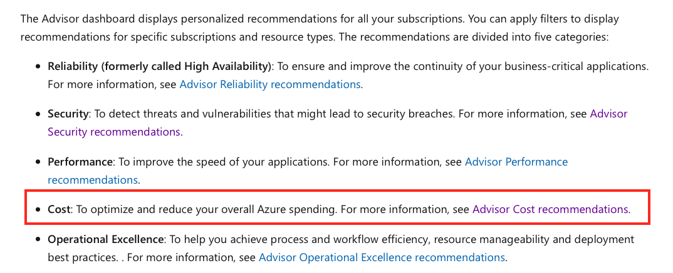

Bottom of Form

Top of Form

Question 43: **Incorrect**

Please evaluate if the following statement is **True** or **False**.

Azure Advisor provides many recommendations including virtual machines’ network setting configurations.

* ​

True

**(Incorrect)**

* ​

False

**(Correct)**

**Explanation**

**Microsoft documentation states the following:**

*“Advisor is a personalized cloud consultant that helps you follow best practices to optimize your Azure deployments.*

*The Advisor dashboard displays personalized recommendations for all your subscriptions. You can apply filters to display recommendations for specific subscriptions and resource types.” - microsoft.com*

Azure Advisor provides recommendations and these are split into the following five categories:

**Reliability (formerly called High Availability)**: *“To ensure and improve the continuity of your business-critical applications.” (microsoft.com)*

**Security**: *“To detect threats and vulnerabilities that might lead to security breaches.”* *(microsoft.com)*

**Performance**: *“To improve the speed of your applications.” (microsoft.com)*

**Cost**: *“To optimize and reduce your overall Azure spending.” (microsoft.com)*

**Operational Excellence**: *“To help you achieve process and workflow efficiency, resource manageability and deployment best practices.” (microsoft.com)*

Coming back to this scenario, Azure Advisor doesn’t provide any kind of recommendations that could help you decide how to configure the network settings for your virtual machines. It is really up to you to decide what are the traffic flows that you need to configure and allow throughout your Azure infrastructure.

Also, and this is pretty obvious, Azure can’t really know what you need to happen in your infrastructure, so it can’t provide any recommendations related to your virtual machines’ network configuration.

**Reference:**

<https://docs.microsoft.com/en-us/azure/advisor/advisor-overview>

**Quick Preview:**

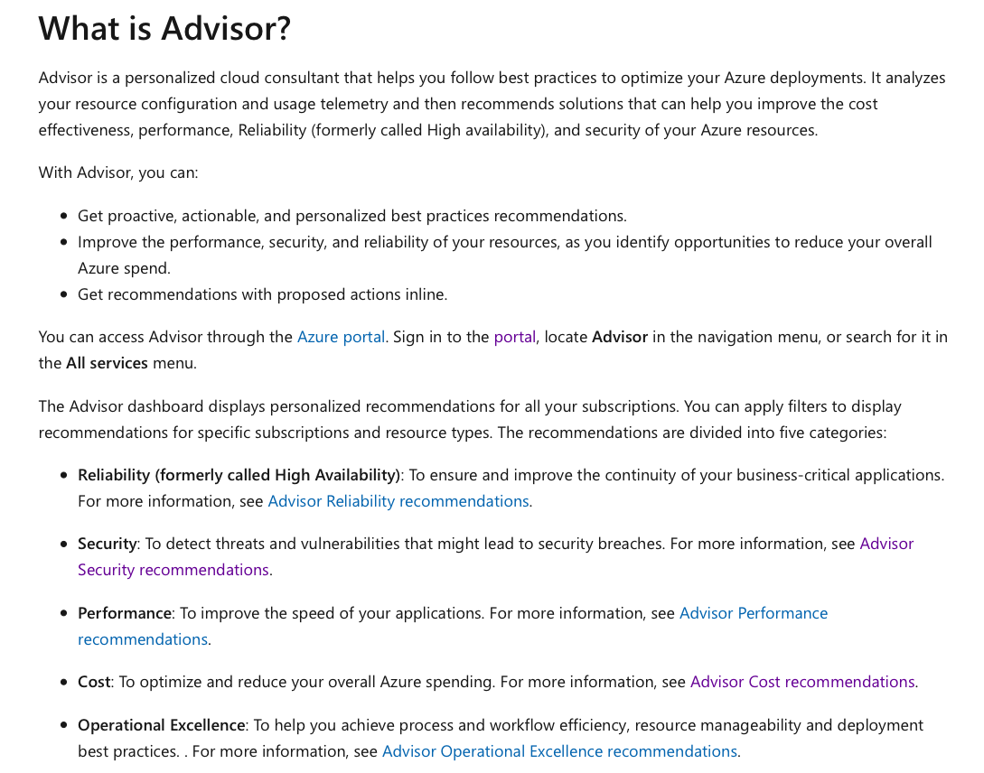

Bottom of Form

Top of Form

Question 44: **Correct**

Which of the following services provides a cloud-based Enterprise Data Warehouse (EDW) ?

* ​

Azure Synapse Analytics

**(Correct)**

* ​

Azure Database for PostgreSQL

* ​

Azure Cosmos DB

* ​

Azure SQL Database

**Explanation**

Azure Data Warehouse has been rebranded under a new name – Azure Synapse Analytics. Azure Synapse service combines Big Data analytics and data warehousing.

**Microsoft documentation states the following:**

*“Azure Synapse brings these two worlds together with a unified experience to ingest, prepare, manage, and serve data for immediate business intelligence and machine learning needs.”*

**Reference:**

<https://docs.microsoft.com/en-us/azure/synapse-analytics/sql-data-warehouse/sql-data-warehouse-overview-what-is>

**Quick Preview:**

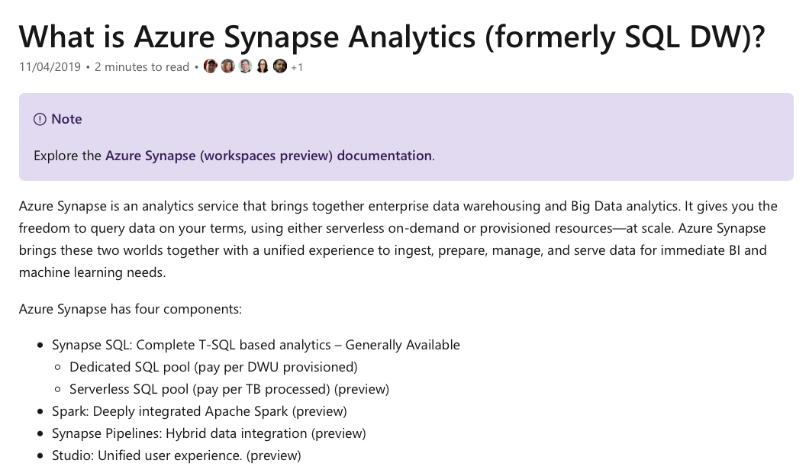

Bottom of Form

Top of Form

Question 45: **Correct**

You received a new task to generate high probability predictions.

Which of the following services would you use ?

* ​

Azure Machine Learning

**(Correct)**

* ​

Azure Synapse Analytics

* ​

Azure Functions

* ​

Azure IoT Hub

**Explanation**

Indeed, artificial intelligence and machine learning topics are hot and very much up-to-date.

Machine learning and machine learning models can definitely help you for this task. The corresponding Azure service that you can use for this task is Azure Machine Learning.

First, you would need to train a machine learning model which can afterwards make predictions. For example, you could train a machine learning model that recognizes oranges from pictures. In order to develop and train a machine learning model that provides predictions with high probability, you would need to analyze as many pictures as possible with oranges.

Once training is complete, you can then present a brand-new picture to your machine learning model which will then make a prediction. The prediction could sound similar to … “this is an orange and I am 90% sure”.

**Microsoft documentation states the following:**

*“Azure Machine Learning is a cloud-based environment that you can use to train, deploy, automate, manage, and track machine learning (ML) models.*

*Machine learning is a data science technique that allows computers to use existing data to forecast future behaviors, outcomes, and trends. By using machine learning, computers learn without being explicitly programmed.” - microsoft.com*

**Reference:**

<https://docs.microsoft.com/en-us/azure/machine-learning/overview-what-is-azure-ml>

**Quick Preview:**

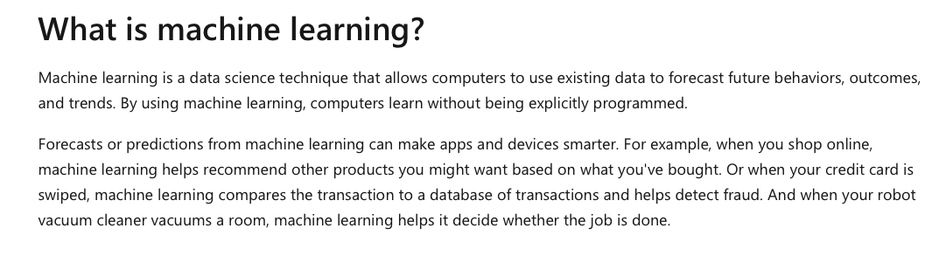

Bottom of Form

Top of Form

Question 46: **Correct**

You are designing in Azure a new weather app that needs to be able to process data coming from millions of sensors.

Which of the following Azure services is able to perform this task?

* ​

Azure Machine Learning

* ​

Azure Synapse Analytics

* ​

Azure Functions

* ​

Azure IoT Hub

**(Correct)**

**Explanation**

For this specific scenario you would use Azure IoT Hub. Azure IoT Hub service is able to receive and process Data from millions of IoT devices.

For example, think of agriculture use cases, where you could have all kind of sensors and devices literally deployed on the field and sending data to your IoT hub. Or maybe you are managing a fleet of trucks, and all the data is received and processed by Azure IoT Hub service.

**Microsoft documentation states the following:**

*“IoT Hub is a managed service, hosted in the cloud, that acts as a central message hub for bi-directional communication between your IoT application and the devices it manages.*

*You can use Azure IoT Hub to build IoT solutions with reliable and secure communications between millions of IoT devices and a cloud-hosted solution backend. You can connect virtually any device to IoT Hub.” - microsoft.com*

**Reference:**

<https://docs.microsoft.com/en-us/azure/iot-hub/about-iot-hub>

**Quick Preview:**

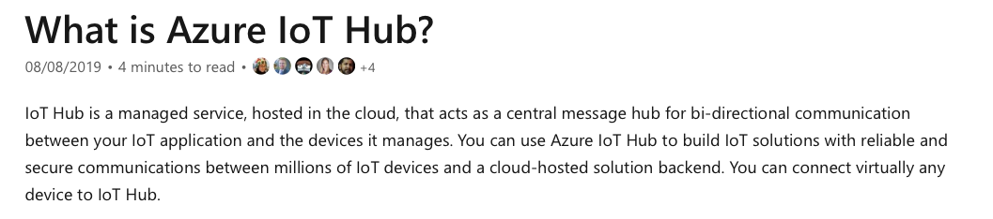

Bottom of Form

Top of Form

Question 47: **Correct**

Your company has decided to add a watermark to Microsoft Word documents that contain credit card information.

Which of the following Azure services would you use in order to accomplish this task?

* ​

Azure Information Protection

**(Correct)**

* ​

Azure policies

* ​

DDoS protection

* ​

Azure Identity Protection

**Explanation**

Azure Information Protection is an Azure service that you can use to classify and protect documents and emails, by applying labels.

**Microsoft documentation states the following:**

*“For example, your administrator might configure a label with rules that detect sensitive data, such as credit card information. In this case, any user who saves credit card information in a Word file might see a tooltip at the top of the document with a recommendation to apply the relevant label for this scenario.” - microsoft.com*

Important to note is that labels can classify and **optionally** protect your documents, so extra configuration needs to be performed in order to actually protect your documents as well.

**Microsoft documentation states the following:**

*“Labeling your content with AIP includes:*

- *Classification that can be detected regardless of where the data is stored or with whom it's shared.*

- *Visual markings, such as headers, footers, or****watermarks****.*

- *Metadata, added to files and email headers in clear text.” - microsoft.com*

**Reference:**

<https://docs.microsoft.com/en-us/azure/information-protection/what-is-information-protection>

**Quick Preview:**

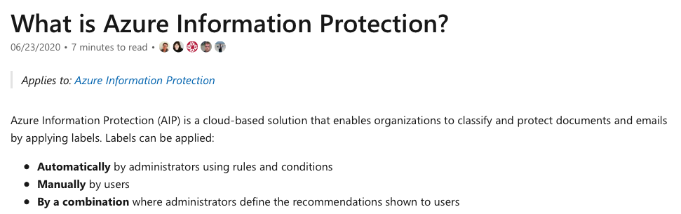

Bottom of Form

Top of Form

Question 48: **Correct**

Please evaluate the following statement and decide if it is **True** or **False**:

Azure Cognitive Services represents a simplified tool to build Artificial Intelligence (AI) applications.

* ​

True

**(Correct)**

* ​

False

**Explanation**

Azure Cognitive Services are great to use when you need to build cognitive intelligence into your applications. Cognitive capabilities that you can add to your apps are available in Azure under the following categories: Vision, Speech, Language, Decision and Search.

**Microsoft documentation states the following:**

*“You can add cognitive features to your applications without having artificial intelligence (AI) or data science skills.*

*Azure Cognitive Services comprise various AI services that enable you to build cognitive solutions that can see, hear, speak, understand, and even make decisions.” - microsoft.com*

So, because you don’t need to have advanced knowledge on either artificial intelligence or machine learning, that is really why Azure Cognitive Services represent a simplified tool to use.

**Reference:**

<https://azure.microsoft.com/en-gb/services/cognitive-services/>

<https://docs.microsoft.com/en-gb/azure/cognitive-services/what-are-cognitive-services>

**Quick Preview:**

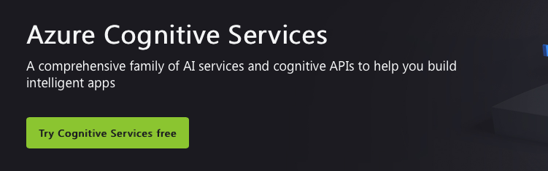

Bottom of Form

Top of Form

Question 49: **Correct**

ABC Corporation has recently completed the migration of all its services to Microsoft Azure. . ABC Corporation CEO wants to understand what kind of data will Microsoft have access to, how will Microsoft process the data and for what purposes.

Which of the following would you use to clarify the CEOs doubts?

* ​

Microsoft Online Services Privacy Statement

**(Correct)**

* ​

Microsoft Online Services Terms

* ​

Microsoft Online Service Level Agreement

* ​

Online Subscription Agreement for Microsoft Azure

**Explanation**

The Microsoft Privacy Statement can definitely help you to bring clarifications on the topic. The Microsoft Privacy Statement also known as Microsoft online services privacy statement, covers all the information that the CEO is asking for.

For example, the statement clearly present what personal data on Microsoft collets, how will the data be used, how to access and control your personal data and a whole lot more.

**Microsoft documentation states the following:**

*“Your privacy is important to us. This privacy statement explains the personal data Microsoft processes, how Microsoft processes it, and for what purposes.*

*Microsoft collects data from you, through our interactions with you and through our products. You provide some of this data directly, and we get some of it by collecting data about your interactions, use, and experiences with our products.*

*The data we collect depends on the context of your interactions with Microsoft and the choices you make, including your privacy settings and the products and features you use.” - microsoft.com*

**Reference:**

<https://privacy.microsoft.com/en-us/privacystatement>

**Quick Preview:**

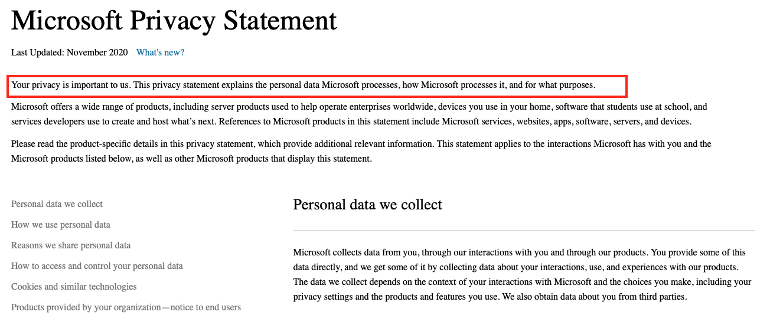

Bottom of Form

Top of Form

Question 50: **Correct**

Please evaluate the cloud models below and match them to the correct cloud advantage:

1. Hybrid cloud    A. No capital expenditure or initial investments are needed.

2. Private cloud   B. You have full control over security.

3. Public cloud    C. Use either on-premises or cloud-based resources.

* ​

1 - B, 2 - C, 3 - A

* ​

1 - C, 2 - B, 3 - A

**(Correct)**

* ​

1 - B, 2 - A, 3 - C

* ​

1 - C, 2 - A, 3 - B

**Explanation**

Correct mapping as below:

1. Hybrid cloud - Provides a choice to use on-premises or cloud-based resources.

2. Private cloud - Provides complete control over security.

3. Public cloud - No required capital expenditure.

While using public cloud, there is no upfront investment for you, no CapEx, as you rent resources from the public cloud provider, such as Azure.

Private cloud deployment model provides complete control over security because you are running your own servers and you can configure them as you want. Also, you may also keep your private data center not connected to Internet, which increases the security level.

Hybrid cloud is a mix of public and private cloud deployment models, which means that you can run your apps both in public and private clouds.

**Reference:**

<https://azure.microsoft.com/en-us/overview/what-are-private-public-hybrid-clouds/#overview>

**Quick Preview:**

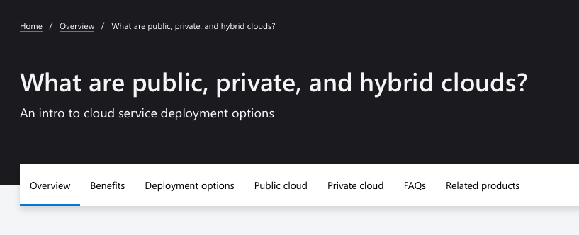

Bottom of Form

Top of Form

Question 51: **Correct**

You are running 20 virtual machines in your on-premises data center and 30 virtual machines in Azure cloud. Applications running in your organization use data available on both Azure VMs and on-premises VMs.

Which type of cloud model is this?

* ​

hybrid

**(Correct)**

* ​

private

* ​

public

**Explanation**

While using public cloud, there is no upfront investment for you, no CapEx, as you rent resources from the public cloud provider, such as Azure. This also means that all your applications and services are deployed and run in Azure only.

While using a private cloud deployment model, you are running your applications and services on your own servers only.

**Hybrid cloud** is a mix of public and private cloud deployment models, which means that you run your apps both in public and private clouds.

The scenarios mentions that applications interact with virtual machines running both in Azure and in an on-premises environment, so this is a hybrid cloud deployment model.

**Reference:**

<https://azure.microsoft.com/en-us/overview/what-are-private-public-hybrid-clouds/#overview>

**Quick Preview:**



Bottom of Form

Top of Form

Question 52: **Correct**

Please evaluate the following statements and decide if they are **True** or **False**:

1. If you buy servers for your data center, you are making an operational expenditure (OpEx) investment.

2. Monthly payments in your organization represent operational expenditure (OpEx) costs.

3. Paying on a monthly basis for software licenses represents operational expenditure (OpEx) costs.

* ​

1 - True, 2 - True, 3 - True

* ​

1 - False, 2 - True, 3 - False

* ​

1 - True, 2 - True, 3 - False

* ​

1 - False, 2 - True, 3 - True

**(Correct)**

**Explanation**

First, let's clarify what operational expenditure (OpEx) and capital expenditure (CapEx) mean. Simply put, CapEx refers to money spent in advance for an investment, for example when buying hardware or equipment, while OpEx refers to money spent on a monthly basis, gradually, like you do for your Azure subscription, every month.

**Statement 1:**

This statement is **False**, because when you build a data center you definitely have to spend money in advance before the company can produce any income. You have to buy equipment, such as servers, storage, networking hardware, security equipment and so on.

On the other hand, the monthly electricity bill for your DC represents OpEx, as you would pay it every month, while you consume electricity.

**Statement 2:**

This statement is **True**. For example, personnel salaries are paid every month, at the end of the month, and ***not upfront or in advance*** for the whole year. This represents an OpEx cost for the company.

**Statement 3:**

This statement is also **True**. Leasing software actually means you pay every month for the software you are using. On the other hand, if you buy software or perpetual licenses, which means that the licenses don't expire and are good for life, this means a one-time payment, so an investment, and represents CapEx costs for the company.

**Reference and Further learning:**

<https://docs.microsoft.com/en-us/azure/cloud-adoption-framework/strategy/business-outcomes/fiscal-outcomes>

**Quick Preview:**

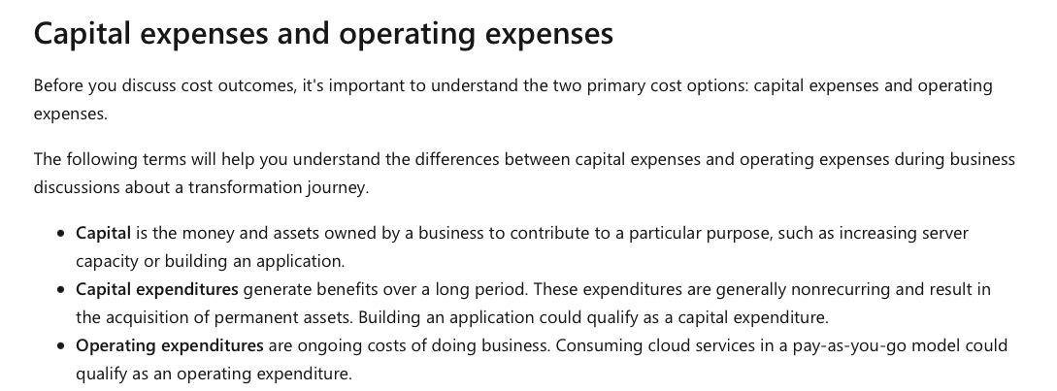

Bottom of Form

Top of Form

Question 53: **Incorrect**

Please select the appropriate option to complete the following sentence:

Azure Availability Zones represent physically separate locations **..........** .

* ​

across two continents

* ​

within a single Azure region

**(Correct)**

* ​

within multiple Azure regions

* ​

within a single Azure datacenter

**(Incorrect)**

**Explanation**

Availability Zones in Azure represent unique physical locations, deployed within an Azure region. Each Availability Zone is made up of one or more data centers equipped with independent power, cooling, and networking. Some Azure regions, **so not all Azure regions**, support Availability Zones.

So, coming back to this questions, an Availability Zone in Azure has physically separate locations (or data centers) within a single Azure region.

**Reference:**

<https://docs.microsoft.com/en-us/azure/availability-zones/az-overview>

**Quick Preview:**

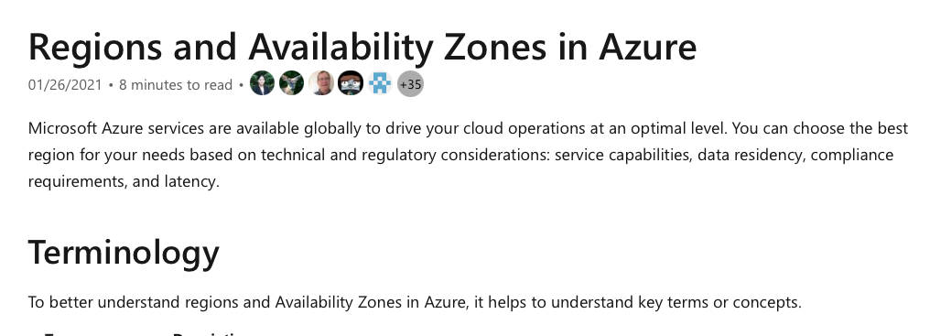

Bottom of Form

Top of Form

Question 54: **Correct**

Please evaluate the following statement and select **Yes** if the statement is true, otherwise select **No**.

You can assign multiple Azure roles to a user account.

* ​

Yes

**(Correct)**

* ​

No

**Explanation**

There are two types of RBAC roles available in Azure: built-in roles and custom RBAC roles. Some common built-in roles are Contributor, Owner and Reader roles.

Roles are assigned to users. Basically, a role includes permissions that you need or want to assign to your users. When you assign a role to a user, you give the user permissions to perform actions, included in the role definition. For example, if you assign a user the Contributor role, the user will be provided full access to manage all resources.

And here is the “catch”… What resources? The RBAC role is applied at one of the levels available in the Azure hierarchy: the actual resource, resource group, subscription and management group. So, if you apply the contributor role on a resource group, for a user, the user will be provided full access to manage all resources in that specific resource group.

Coming back to the scenario presented in this question, imagine that you need to provide a user full access on a resource group and read only rights or permissions to manage resources in a different resource group. Either built in roles or custom roles, you would need to assign multiple roles to your user in order to match the requirements.

For this reason, the statement presented in this scenario is definitely True.

**Reference:**

<https://docs.microsoft.com/en-us/azure/role-based-access-control/custom-roles>

**Quick Preview**

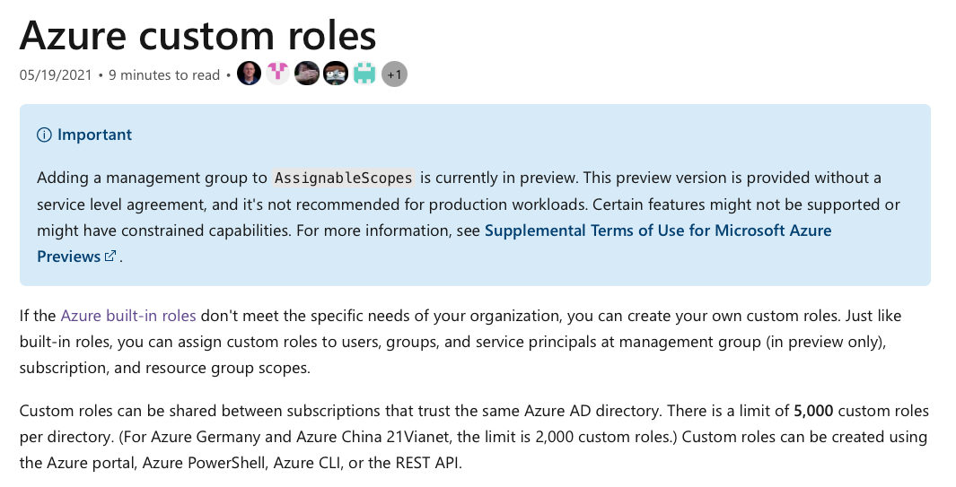

Bottom of Form

Top of Form

Question 55: **Correct**

Please evaluate the statement and select **Yes** if the statement is true, otherwise select **No**.

General availability (GA) Azure services are available to few customers only.

* ​

Yes

* ​

No

**(Correct)**

**Explanation**

Usually, when Microsoft releases a new service, the service is released in private preview phase. During private preview, Microsoft will invite a few customers to test the new service and provide feedback. Also during private preview phase, regular support services are not available.

When the service is mature and considered ready for production environments testin, Microsoft will transition the service to public preview phase. During this phase, any customer can run and test the service. As opposed to private preview, Microsoft teams will provide formal support services in this phase.

The last step is migrating the service to generally available (GA) phase. During public preview phase, there may be functionalities or features fixing as well, but once the service is transitioned to GA, the new service is considered stable and ready for real production workloads. All Azure services in GA are available to all customers. Also, the service is covered by support via all official Microsoft support channels.

And now, coming back to the statement presented in this scenario, we can clearly state that **Azure Generally Available (GA) services are available to all Azure customers.**

**Reference:**

<https://azure.microsoft.com/en-gb/support/legal/preview-supplemental-terms/>

**Quick Preview:**



**I hope you enjoyed this practice course, can I ask you to leave a review for this course?** I'd love to hear about your experience, this helps me keep going and create more Azure content for the community. Thank you so much!

**Best of luck with your AZ-900 exam and please let me know how it went. Reading success stories is the most rewarding aspect for me and I am confident that yours will be next!**

I look forward to seeing you again,

Bottom of Form